Patna University


DEPARTMENT OF STATISTICS,

Master’s In Computer Application
Session 2024-2026
A
Project Report
On
Android App Authenticity
Prediction System

Patna University



DEPARTMENT OF STATISTICS, MCA Program, PU
A
Project Report
On
Android App Authenticity Prediction System
This is submitted to partial fulfillment of award for Master of Computer Applications.
Submitted by:
Sr. No. | Name | Registration No. | Exam Roll No.
 | Aarush Singh | 202430700009 | 42610212044
 | Dhananjay Kumar Sharma | 202430700015 | 42610212022
 | Chanchal Kumari | 203202101261 | 42610212028
 | Mritunjay Kumar | 202430700023 | 42610212008

Under the guidance of:
Jai Bardhan Kanth

Signature of External
Signature of Internal

This is to certify that the project titled “ANDROID APP AUTHENTICITY PREDICTION SYSTEM”, submitted by Aarush Singh, Dhananjay Kumar Sharma, Chanchal Kumari, and Mritunjay Kumar, students of Patna University, is an original work carried out by us under the guidance of Mr. Jai Bardhan Kanth Sir as a part of the academic curriculum.
We hereby declare that this project has not been submitted to any other university or institution for the award of any degree or diploma. All sources of information and references used in this project have been properly acknowledged.

External Examiner
Project Guide
______________________ ________________________

We would like to express our respect and gratitude to our internship supervisor Jai Bardhan Kanth, Assistant Professor, Department of Statistics, Patna University, Patna, for their expertise, guidance, enthusiastic, involvement and encouragement throughout this dissertation work. We are grateful to them for providing us constant motivation leading to successful completion of this work.
We would like to express our sincere gratitude to Patna University, Patna for providing us the opportunity to work on this project titled “Android App Authenticity Prediction System”.
We would also like to thank the faculty members and department staff for their assistance and technical support during the completion of this project.
Finally, we extend our gratitude to our friends and family members for their motivation and encouragement throughout the project work.

This project developed a robust machine learning model to predict the authenticity of Android applications, crucial for user safety and platform integrity. Utilizing a dataset of 29,999 apps with 184 features, the methodology involved comprehensive data wrangling—addressing duplicates, missing values in 'App', 'Description', 'Related apps', and 'Dangerous permissions count'—followed by extensive Exploratory Data Analysis (EDA). EDA highlighted dominant app categories like 'Tools' and 'Entertainment', identified that free apps are prevalent and generally higher-rated than paid apps, and revealed a significant class imbalance with malicious apps forming a minority. Hypothesis testing confirmed a statistically significant relationship between dangerous permissions and average ratings, a difference in ratings between free and paid apps, and varying rating consistency across app categories.
Feature engineering encompassed outlier treatment (5th and 95th percentile capping), one-hot encoding for categorical features ('Category', 'Permission_Category'), and detailed textual data preprocessing (contraction expansion, lowercasing, punctuation/URL removal, stopword removal, lemmatization) before TF-IDF vectorization. Dimensionality was managed through Select K Best with f_classif, retaining the top 100 features, and skewed numerical features were transformed using log1p. The data was then scaled using StandardScaler and split into an 80/20 train-test set with stratification.
Three machine learning models were implemented and hyperparameter-tuned: Logistic Regression, Decision Tree Classifier, and Random Forest Classifier. The Tuned Random Forest Classifier emerged as the top-performing model, achieving an Accuracy of 0.8140, Precision of 0.8779, and an F1-Score of 0.8574. Despite a slightly lower ROC AUC (0.8019) compared to Logistic Regression, its superior balance of precision and recall makes it ideal for mitigating false positives (legitimate apps wrongly flagged) and false negatives (malicious apps undetected), thereby significantly contributing to user safety and maintaining platform trust. This model offers a reliable and effective solution for automated Android app authenticity prediction.

S no. | Content | Page no.
01 | Preface
02 | Tool and Environment
03 | Introduction
04 | Objective
05 | System Requirement
06 | Modules
07 | Dataset Attribute & Relations
08 | DFD
09 | Data processing & EDA
10 | ML Model Implementation
11 | Observation
12 | Model Selection
13 | User Interface
14 | Testing and Debugging
15 | Future Scope
16 | Limitations
17 | Conclusion
18 | Bibliography

It is a great opportunity for us to have a Master in Computer Application from Patna University. In the accomplishment of this degree, we are submitting a project report on “ANDROID APP AUTHENTICITY PREDICTION SYSTEM”. Subject to the limitation of time, effort and resources every possible attempt has been made to study the problem deeply.
In an increasingly digital world, the proliferation of mobile applications has transformed how we live, work, and interact. Among these, Android applications stand out due to their vast ecosystem and widespread adoption. However, this expansive growth also brings significant challenges, particularly concerning app authenticity and security. Malicious applications pose substantial threats to user privacy, device integrity, and the overall trust in app marketplaces.
This project, Android Authenticity Prediction, addresses this critical challenge head-on. Our aim is to develop a robust and automated machine learning solution capable of accurately distinguishing authentic Android applications from potentially malicious or undesirable ones. By leveraging a comprehensive dataset and applying a meticulous methodology encompassing data wrangling, exploratory data analysis, hypothesis testing, and advanced machine learning techniques, we sought to build a predictive model that enhances user safety and strengthens platform integrity.
This document details the journey from raw data to a fully evaluated predictive model, highlighting the steps taken to understand the data, engineer meaningful features, and rigorously test various machine learning algorithms. The ultimate outcome is a highly effective model designed to mitigate false positives and false negatives, thereby contributing significantly to a safer and more trustworthy Android app environment. This work underscores the continuous effort required to safeguard digital ecosystems against evolving threats.
We are not limited to study but also implemented our findings using a Streamlit UI for interaction with ML model.
The link of code published on GitHub:
Github Repository Link
Thel link of google colab notebook in which the project was
Codes on Googel Colab

- IDEs (Integrated Development Environments):
  - Spyder: Spyder is used as the primary IDE for developing and testing the Python codebase. Its interactive nature and built-in debugging features enhance the development process.
  - PyCharm: PyCharm is another essential IDE utilized for the project. Its powerful code analysis and intelligent coding assistance aid in writing efficient and error-free code.
- Version Control System:
  - Git: Git is employed as the version control system to track changes and manage the project's source code effectively. It allows collaborative development and ensures code integrity.
- Cloud Platform:
  - Render Cloud: The project is deployed on Render Cloud, a scalable cloud platform, to ensure high availability and efficient processing of incoming messages.
- Hardware Requirements:
  - Processor: Intel Core i5 or higher.
  - RAM: 8 GB or higher.
  - Storage: Sufficient storage space for the development environment and datasets.
- Software Requirements:
  - Operating System: Windows, macOS, or Linux.
  - Python 3: Python is the core programming language used for implementing the spam detection algorithms.
  - Flask: The web framework Flask is employed to develop the user-friendly web application interface.
  - Natural Language Toolkit (NLTK): NLTK is utilized for advanced NLP tasks, such as text preprocessing and feature extraction.
  - Pandas and NumPy: These libraries are used for data manipulation and numerical computations.
  - Scikit-learn: Scikit-learn is employed for implementing machine learning algorithms for spam detection.
  - HTML and CSS: HTML and CSS are used to design the web application interface.

Additional requirements
- Scipy: Scipy is utilized for scientific and technical computing tasks, providing essential functionalities for numerical optimization, statistical analysis, and mathematical operations.
- NLTK (Natural Language Toolkit): NLTK plays a vital role in the project by providing comprehensive support for natural language processing tasks, including text preprocessing, tokenization, and feature extraction.
- Matplotlib: Matplotlib is employed for data visualization, enabling the generation of graphs, charts, and visual representations of data for analysis and interpretation.
Jinja2 (Markupsafe): Jinja2 is utilized as the templating engine for the web application interface, enabling dynamic content rendering and improving the user experience
The global proliferation of smartphones has established the Android ecosystem as the most widely used mobile operating system in the world. While this open-source nature has fostered immense innovation and accessibility, it has simultaneously created a massive surface area for cyber threats. In recent years, there has been a significant surge in the development of malicious and counterfeit applications designed to bypass traditional security filters.
These fraudulent applications pose a multi-dimensional threat to the digital landscape. Beyond simple performance issues, they are often engineered for data exfiltration, harvesting sensitive personal information, and facilitating financial fraud. Furthermore, sophisticated malware can compromise device integrity, turning personal hardware into a tool for botnet activities or ransomware.
To combat this evolving threat, this project proposes an Android App Authenticity Prediction System powered by advanced Machine Learning (ML) algorithms. Unlike traditional signature-based detection, which often fails against "zero-day" or mutated threats, this system leverages a data-driven approach to identify hidden risks. By analysing high-dimensional features such as system permission requests, application categories, and runtime behavior patterns, the ML model can distinguish between authentic software and deceptive mimics with high precision.
The primary objective of this research is to bridge the security gap for both end-users and developers. By providing a reliable, automated layer of verification, this system enhances the overall security, reliability, and trustworthiness of the mobile application environment.
Problem Statement
The Android ecosystem hosts millions of applications, with thousands of new apps being uploaded to various marketplaces daily. Given this massive volume, manual verification and code auditing of every application have become humanly impossible. Traditional security checks often struggle to keep pace with the sheer speed of app production.
The core issues include:
- Scale and Volume: With over 3 million apps on the Google Play Store alone, security teams cannot manually inspect each update for hidden malicious intent.
- Deceptive Mimicry: Malicious developers are increasingly creating "Fake Apps" that look identical to popular banking or social media tools, making it nearly impossible for an average user to distinguish between an authentic and a fraudulent application.
- Dynamic Threats: Modern malware is often "polymorphic," meaning it changes its code structure frequently to evade simple scanners, creating a critical need for an automated, intelligent detection system.

Motivation
The primary motivation behind this project is the critical need to evolve from Signature-based detection to Behavior-based detection.
- Limitations of Traditional Methods: For years, antivirus software relied on "signatures" (specific code patterns). However, if a hacker changes even a small part of the code, the signature changes, and the traditional scanner fails to recognize the threat. This is known as a Zero-Day attack.
- The Shift to Intelligence: Instead of looking at what the app is (its code signature), this project focuses on what the app does (its behavior). By analyzing requested permissions, intent filters, and hardware access patterns, we can identify "Malicious Intent" even if the malware is brand new.
- Empowering the User: Most users grant permissions (like access to Contacts or SMS) without understanding the risk. The motivation here is to build a system that acts as an intelligent shield, using Machine Learning to process complex data patterns that a human eye would likely miss.
- Proactive Security: By leveraging algorithms like Random Forest or SVM, we can move from "Reactive" security (fixing things after an attack) to "Proactive" security (identifying the threat before the app is even installed).

The primary objective of this project is to develop a robust and automated system capable of verifying the legitimacy of Android applications. By leveraging Machine Learning, the system aims to provide a proactive defense mechanism against the rising tide of fake and malicious apps.
The specific objectives are outlined below:
1. Technical Objectives
- Feature Extraction and Analysis: To identify and extract critical features from Android application files (APKs), such as system permissions, hardware access requests, and API call patterns.
- Model Development: To implement and train multiple Machine Learning algorithms (such as Random Forest, Logistic Regression and Decision Tree) to classify applications as 'Authentic' or 'Malicious'.
- Predictive Accuracy: To optimize the model for high precision and recall, ensuring that legitimate apps are not wrongly flagged (False Positives) while maintaining a high detection rate for threats.
- Pattern Recognition: To detect hidden behavioral correlations in "fake" apps that often mimic the UI of popular applications but request unnecessary and dangerous permissions.
2. Functional Objectives
- Automated Verification: To reduce the need for manual code auditing by providing an automated tool that can quickly scan and predict app authenticity.
- Risk Assessment: To provide a reliability score or classification for any given Android application based on its historical data and requested features.
- Scalability: To design a system architecture that can be scaled to handle large datasets of modern Android applications.
3. End-User & Security Goals
- Data Protection: To safeguard user privacy by identifying applications designed for data exfiltration and unauthorized surveillance.
- Enhancing Trust: To provide developers and users with a tool that ensures the integrity of the software being installed on personal devices.
- Mitigating Financial Loss: To prevent the installation of "Adware" or "Premium SMS" malware that can lead to unexpected financial charges for the user
Hardware Requirements:
- Minimum 8GB RAM (16 GB recommended)
- Intel i5 or higher processor
- 20GB available storage
Software Requirements:
- Operating System: Windows/Linux/macOS
- Python 3.12
- Development Tools: Jupyter Notebook, Google Colab or VS Code
- Libraries: NumPy, Pandas, Matplotlib, Seaborn, Scikit-learn
These tools are essential for data analysis, visualization, and model training.

The system is divided into multiple modules:
1. Data Collection – Gathering dataset of Android applications.
2. Data Preprocessing – Cleaning data, handling missing values, normalization.
3. Feature Selection – Identifying key features affecting authenticity.
4. Model Training – Applying ML algorithms such as Logistic Regression or Decision Tree.
5. Evaluation – Measuring performance using accuracy, precision, recall.
6. Prediction – Classifying apps as authentic or fake.
Each module plays an important role in building an efficient system

Business Context
This dataset consists of apps needed permissions during installation and run-time. We collect apps from three different sources: google play, third-party apps and malware dataset. This file contains more than 30,000 Android apps. features extracted at the time of installation and execution. One file contains the name of the features and others contain a .apk file corresponding to extracted permissions with respective packages. Apps are collected from Google's play store, hiapk, app china, Android, mumayi , gfan slideme, and pandaapp. These .apk files collected from the last three years continuously contain 81 distinct malware families. But, here we are only supposed to predict whether the app is benign(0) or malware(1).

Dataset Description
The foundation of this project is a comprehensive dataset comprising over 30,000 Android applications, curated over a continuous period of three years. This dataset provides a granular view of application behavior by capturing permissions and metadata at both the installation and execution phases.
1. Core Metadata & Engagement Metrics
Before analyzing permissions, the dataset captures the "identity" of the app. These features help the model identify if certain categories (like 'Antivirus' or 'Tools') are more prone to being spoofed by malware.
- Identification: App Name, Package Name, and Category.
- Social Proof: User Ratings (out of 5), Number of Ratings, and App Description.
- Market Data: Price and Related Apps (to identify cluster behaviors).
2. Feature Categorization (The Feature Vector)
The dataset extracts binary flags (0 for No, 1 for Yes) across several critical security domains. These are divided into Safe (S) and Dangerous (D) permissions:
A. System & Hardware Control
These features track how an app interacts with the physical device. Malware often requests these to gain persistence or spy on the user.
- Hardware: Access to Camera, Flashlight, Vibrator, and Audio Recording.
- System Tools: Ability to boot at startup, modify global system settings, format external storage, or prevent the device from sleeping.
- Control: Powering the device on/off, forcing reboots, or killing background processes.
B. Network & Communication
Features in this category are vital for detecting "Trojan" behavior, where an app exfiltrates data to a remote server.
- Connectivity: Full Internet access, Wi-Fi state monitoring, and Bluetooth administration.
- Data Transfer: Downloading files without notification and receiving data from the internet.
C. Personal Information & Messaging
This is the most sensitive category, often targeted by "Spyware."
- User Data: Reading/Writing contact data, browser history, bookmarks, and calendar events.
- Messaging: Reading/Writing SMS, MMS, and Instant Messages; intercepting outgoing calls.
- Accounts: Access to Google Service configurations, including Gmail, YouTube, and Google Drive account tokens.
D. Location Tracking
- Precision: Fine (GPS) location and Coarse (Network-based) location.
- Deception: Ability to "Mock" location sources for testing.
3. Class Distribution (Target Variable)
The final column, Class, serves as the ground truth for our Machine Learning model:
- 0 (Benign): Applications that operate within expected security boundaries.
- 1 (Malware): Applications exhibiting intrusive or harmful permission patterns.
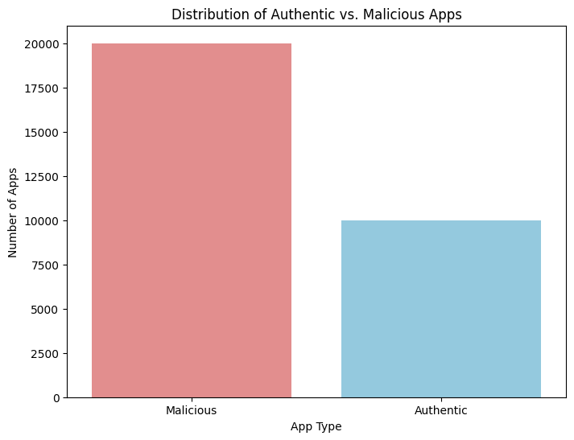
Fig.

Summary of Feature Engineering
The dataset transforms raw APK Manifest files into a structured format containing:
- Total Counts: Aggregated counts of Dangerous (D) and Safe (S) permissions.
- Binary Indicators: Specific flags for over 100+ unique Android permissions.
- Developmental Flags: Indicators for debugging mode or process-limiting tools which are often exploited by advanced malware.

The Level 0 DFD represents the overall system.
It shows how the user interacts with the system and receives output.
Input: App Data provided by the user.
Process: Android Authenticity Prediction System.
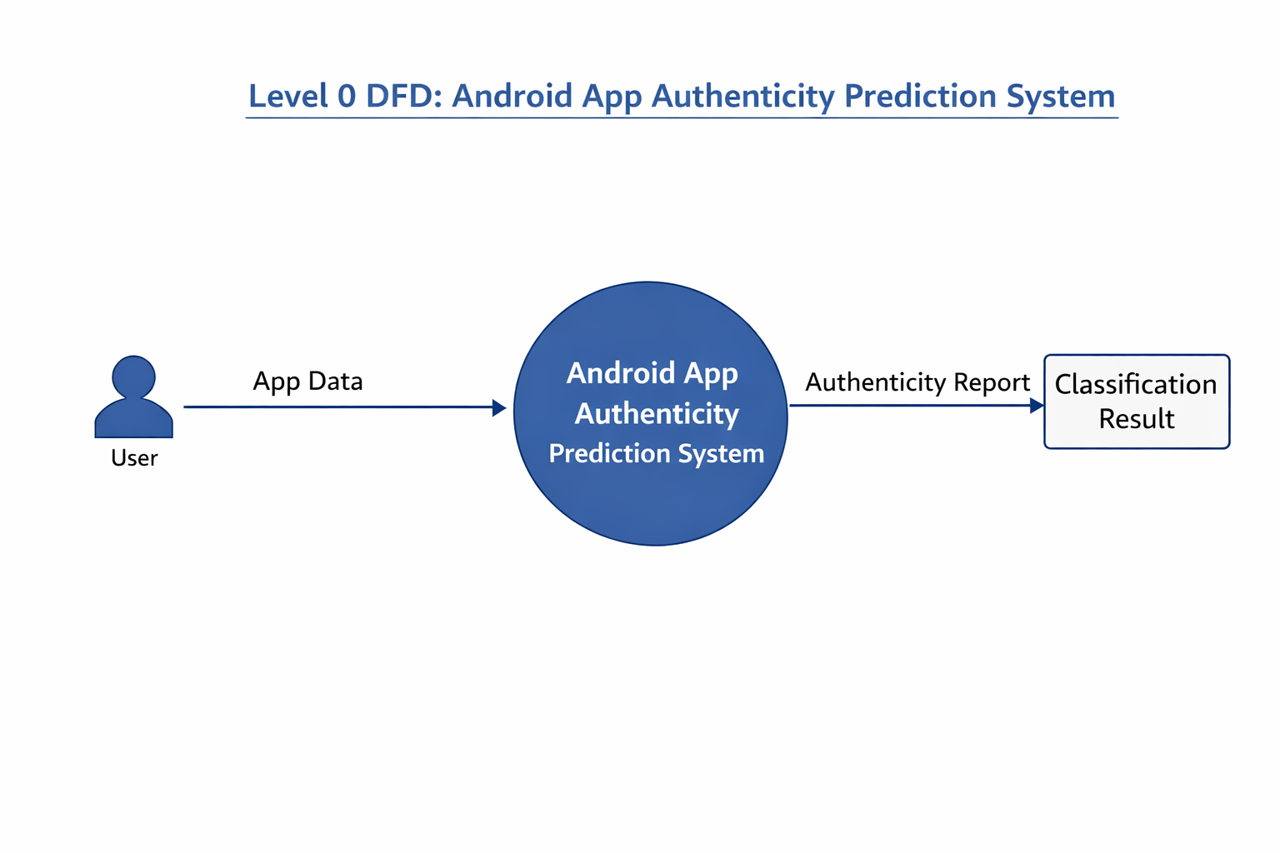
Output: Classification Result (Authentic or Fake).

The Level 1 DFD provides a detailed view of the system workflow.
It includes the following steps:
• App Data Collection
• Data Preprocessing
• Feature Extraction
• Machine Learning Model Training
• Prediction and Analysis
• Final Classification Result
This diagram helps in understanding how data flows through each stage.
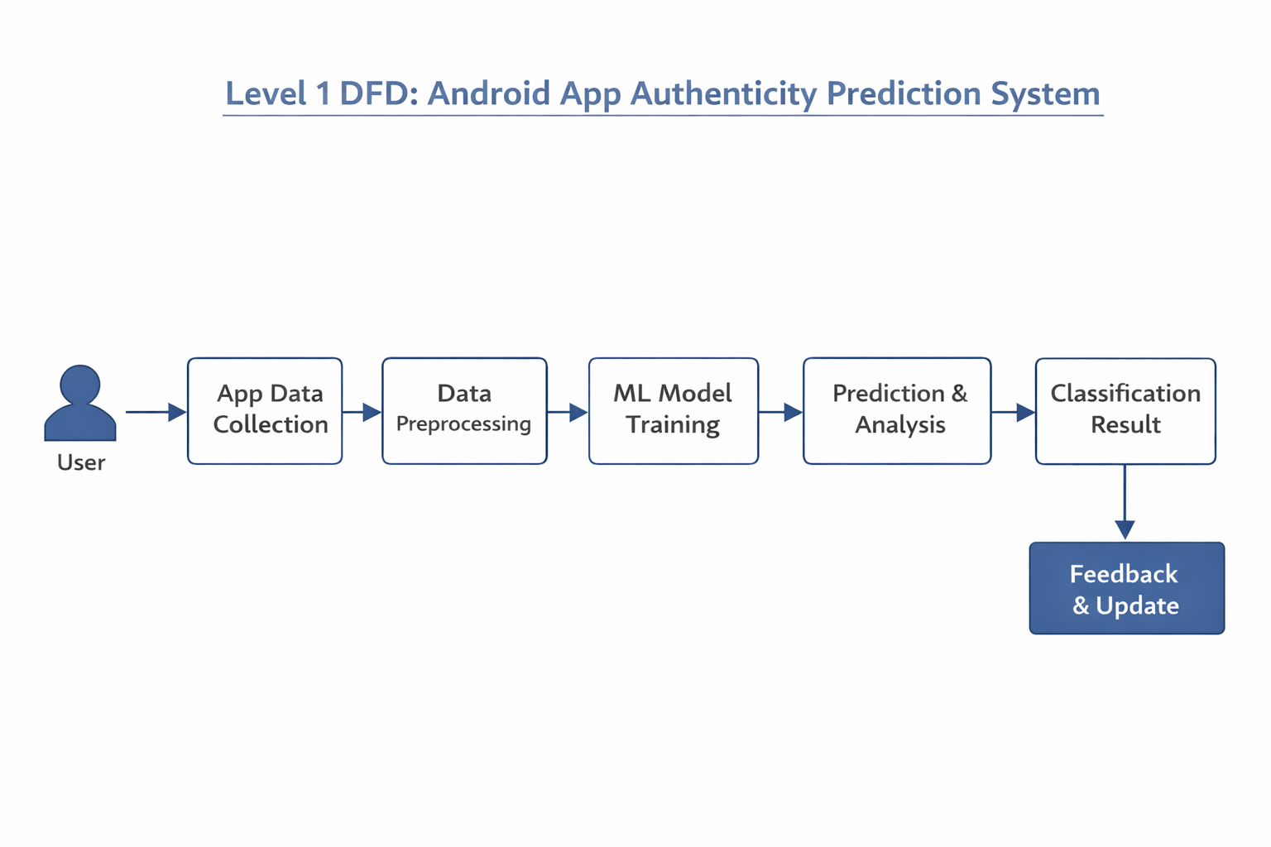

Data Preprocessing:
Data preprocessing refers to the techniques used to transform raw data into a clean, structured, and understandable format, suitable for building machine learning models. Real-world data is often messy, containing errors, inconsistencies, missing values, and irrelevant information. These issues can negatively impact the performance and reliability of a machine learning model, hence the need for preprocessing.
Why is Data Preprocessing Important?
- Improved Model Performance: Clean and well-structured data allows machine learning algorithms to learn more effectively, leading to more accurate predictions and better generalization on unseen data.
- Reduced Training Time: By cleaning and transforming data, you can often reduce the computational resources and time required to train a model.
- Enhanced Data Quality: Preprocessing steps address issues like missing values, inconsistencies, and noise, leading to a higher quality dataset.
- Better Feature Engineering: A preprocessed dataset makes it easier to extract meaningful features that can boost model performance.
- Interpretability: Clean data can lead to more interpretable models, making it easier to understand why a model makes certain predictions.
Common Data Preprocessing Techniques:
- Handling Missing Values:
  - Imputation: Filling in missing values with estimated ones (e.g., mean, median, mode for numerical data; 'unknown' or most frequent for categorical data).
  - Deletion: Removing rows or columns with missing values (if the proportion of missing data is small).
- Handling Outliers:
  - Capping/Flooring: Replacing extreme values with a specified percentile (e.g., 5th and 95th percentiles).
  - Transformation: Applying mathematical functions (e.g., log, square root) to reduce the impact of outliers.
  - Deletion: Removing outlier data points (if they are clearly errors and few in number).

- Data Cleaning:
  - Removing Duplicates: Eliminating identical rows to avoid bias.
  - Standardizing Formats: Ensuring consistency in data entry and representation (e.g., date formats, unit conversions).
  - Correcting Errors: Fixing typos or inconsistencies (e.g., 'NY' vs. 'New York').
- Feature Scaling:
  - Normalization (Min-Max Scaling): Rescaling features to a fixed range, usually 0 to 1.
  - Standardization (Z-score Normalization): Rescaling features to have a mean of 0 and a standard deviation of 1. This is crucial for algorithms sensitive to the magnitude of features (e.g., SVMs, K-Means, Logistic Regression).
- Data Transformation:
  - Log Transformation (e.g., log1p): Used for highly skewed distributions to make them more symmetrical, benefiting models that assume normal distributions.
  - Power Transformations (e.g., Box-Cox): A family of transformations to stabilize variance and make data more Gaussian-like.
- Categorical Encoding:
  - One-Hot Encoding: Converting categorical variables into a numerical format by creating new binary columns for each category. Ideal for nominal categories (no inherent order).
  - Label Encoding/Ordinal Encoding: Assigning a unique integer to each category. Suitable for ordinal categories (where order matters).
  - Target Encoding: Encoding categories based on the mean of the target variable for each category.
- Feature Engineering:
  - Creating new features from existing ones to enhance the model's predictive power (e.g.,total_spent = quantity * price, day_of_week from a date column).

- Dimensionality Reduction:
  - Feature Selection: Choosing a subset of relevant features (e.g., using Select K Best, RFE).
  - Feature Extraction: Transforming features into a lower-dimensional space (e.g., PCA, LDA).
Number of Rows: | 29999
Number of Columns | 184
Data Preprocessing Performed in Colab

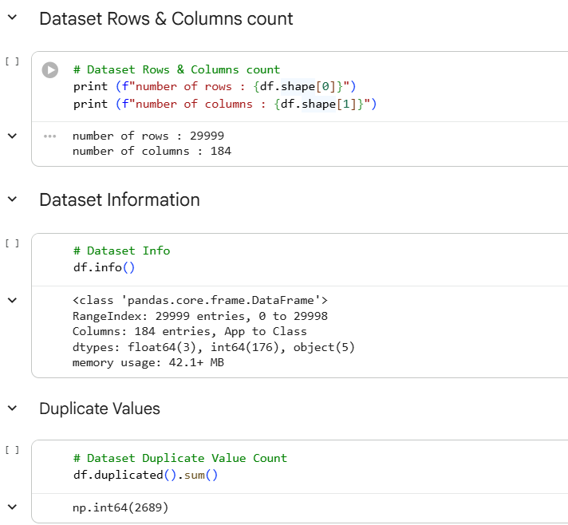

Fig. 1.0 Data Row & Columns Count
 | Missing Count
App | 1
Description | 3
Related Apps | 755
Dangerous Permission Count | 204

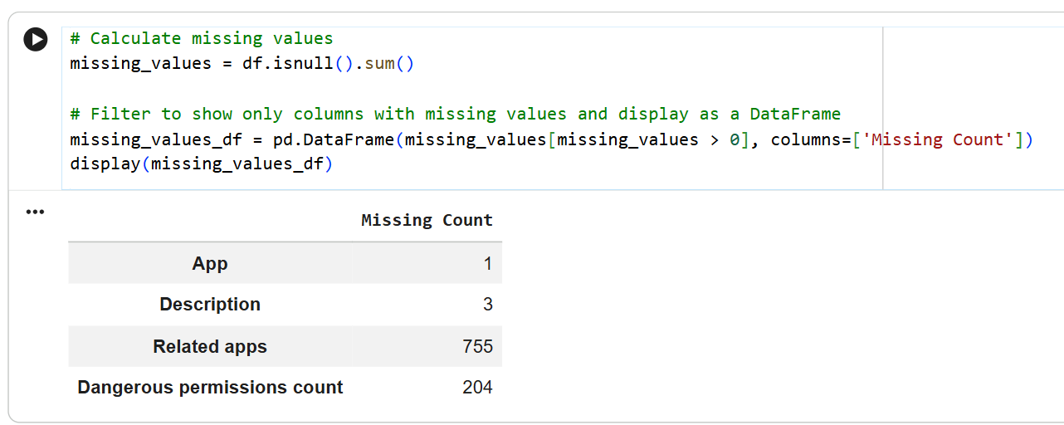

Fig. 2.0 Missing Count
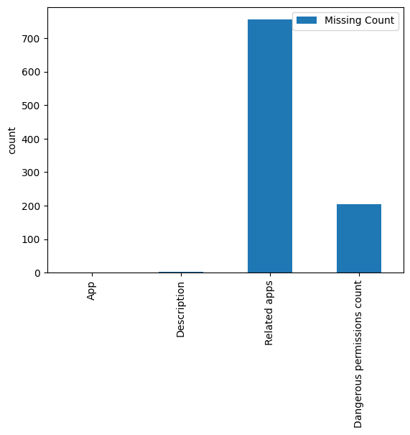
Fig. 3.0 Missing Count Histogram

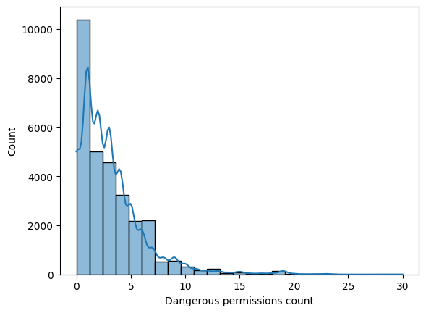
Fig. 4.0 Dangerous Permission Count

Inference from the Dataset
- The dataset contains 29,999 rows and 184 columns.
- The columns include a mix of float64, int64, and object (string) data types.
- There are 2,689 duplicate rows in the dataset.
- The following columns have missing values:
  - App: 1 missing value
  - Description: 3 missing values
  - Related apps: 755 missing values
  - Dangerous permissions count: 204 missing values
This information provides a foundational understanding of the dataset's structure and potential areas requiring data cleaning and preprocessing.

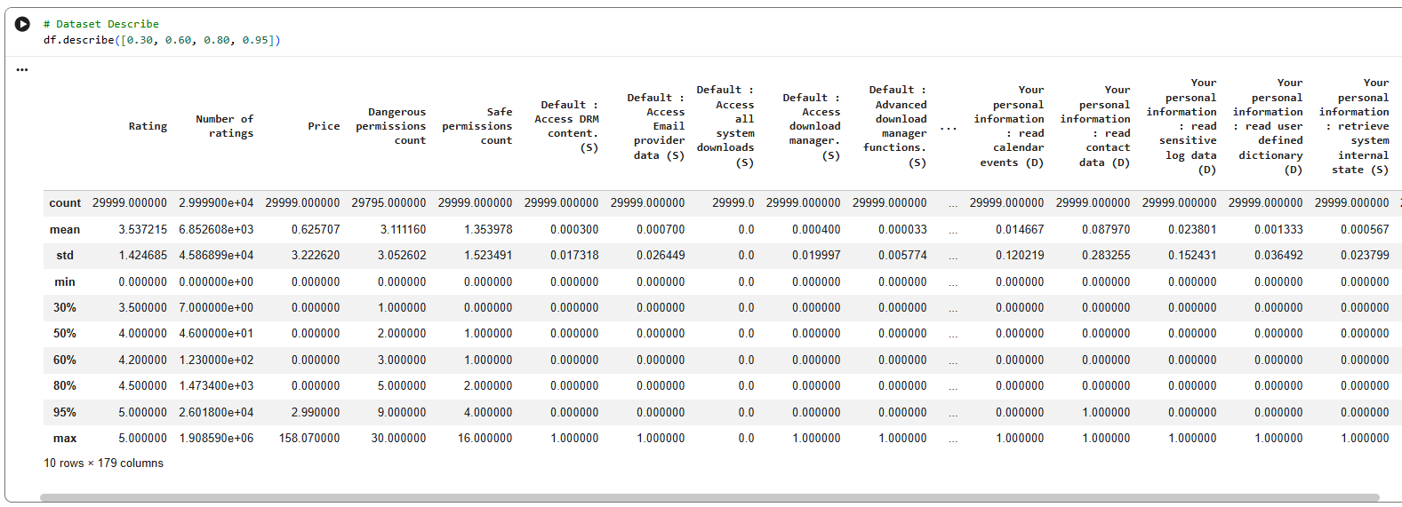

Fig. 5.0 Description of the Dataset
Based on the df.describe() output, here's an overview of the numerical variables in the dataset:
- Rating: The 'Rating' column, representing app ratings, ranges from 0 to 5. The mean rating is approximately 3.54, with a median of 4.0. This suggests that while there are apps with lower ratings, a significant portion of the apps have good to excellent ratings (70% of apps have a rating of 3.5 or higher, and 20% have a rating of 4.5 or higher).
- Number of ratings: This column indicates the number of user ratings an app has received. The values vary widely, from 0 to over 1.9 million. The mean is about 6,852, but the median is much lower at 46, and 95% of apps have 26,018 ratings or fewer. This high standard deviation (45,868) and the large difference between mean and median suggest a highly skewed distribution, with a few very popular apps having a disproportionately high number of ratings.
- Price: The 'Price' column, indicating the cost of the app, shows that most apps are free (median and 80th percentile are 0.0). However, some apps are paid, with the maximum price observed being 158.07. The average price is low (0.63) due to the large number of free apps.
- Dangerous permissions count: This column quantifies the number of dangerous permissions requested by an app. The count ranges from 0 to 30. On average, apps request about 3.11 dangerous permissions. The median is 2, and 95% of apps request 9 or fewer dangerous permissions, suggesting that while some apps ask for many dangerous permissions, most stick to a relatively lower number.
- Safe permissions count: This column represents the number of safe permissions requested. The range is from 0 to 16, with an average of 1.35. The median is 1, and 95% of apps request 4 or fewer safe permissions. This indicates that apps generally request a smaller number of safe permissions compared to dangerous ones.
- Permission-related Binary Columns: Many columns, especially those detailing specific permissions like 'Default : Access DRM content. (S)', 'Default : Access Email provider data (S)', etc., are binary (0 or 1). Their means are very low (e.g., 0.0003 for 'Default : Access DRM content. (S)'), indicating that these specific permissions are rarely granted or requested by the apps in this dataset. The std values are also very low, reinforcing the idea that these are mostly 0s.
Data Wrangling
Data Wrangling, also known as data cleaning or data preprocessing, is a crucial step in any machine learning project. It involves the process of transforming and mapping data from one 'raw' data form into another format with the intent of making it more appropriate and valuable for a variety of downstream purposes, such as analytics and machine learning modeling.

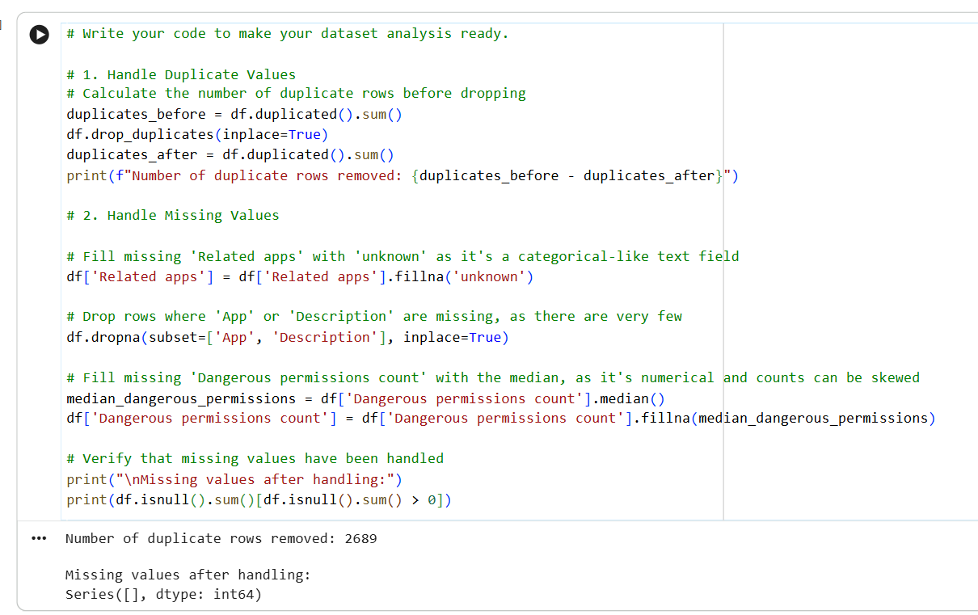

Fig.
To make the dataset analysis-ready, the following manipulations were performed:
- Handling Duplicate Values: Identified and removed 2,689 duplicate rows. Removing duplicates ensures that the model is not biased by redundant information and that each observation is unique, leading to more accurate insights and model training.
- Handling Missing Values:
  - 'Related apps': This column, being of object type with 755 missing values, was imputed by filling NaN values with the string 'unknown'. This approach was chosen to retain all rows, as dropping them would lead to a significant loss of data (approximately 2.5% of the original dataset), and 'unknown' is a reasonable category for apps with no listed related applications.
  - 'App' and 'Description': These columns had 1 and 3 missing values respectively. Given the very small number of missing entries, the corresponding rows were dropped. This is a safe approach when the loss of data is minimal and accurate unique identifiers ('App') or descriptive text ('Description') are crucial.
  - 'Dangerous permissions count': This numerical column had 204 missing values. The missing values were imputed using the median of the column. The median was chosen over the mean because counts often exhibit skewed distributions, and the median is more robust to outliers, providing a more representative central tendency for imputation.
These data wrangling steps ensure that the dataset is clean, consistent, and ready for subsequent stages of exploratory data analysis, feature engineering, and model training, preventing potential errors and improving the quality of insights derived from the data.
Data Vizualization, Storytelling & Experimenting with charts
Chart 1
# Chart - 1 visualization code
plt.figure(figsize=(12, 7))
sns.countplot(y='Category', data=df, order=df['Category'].value_counts().index, palette='viridis')
plt.title('Distribution of App Categories')
plt.xlabel('Number of Apps')
plt.ylabel('Category')
plt.show()

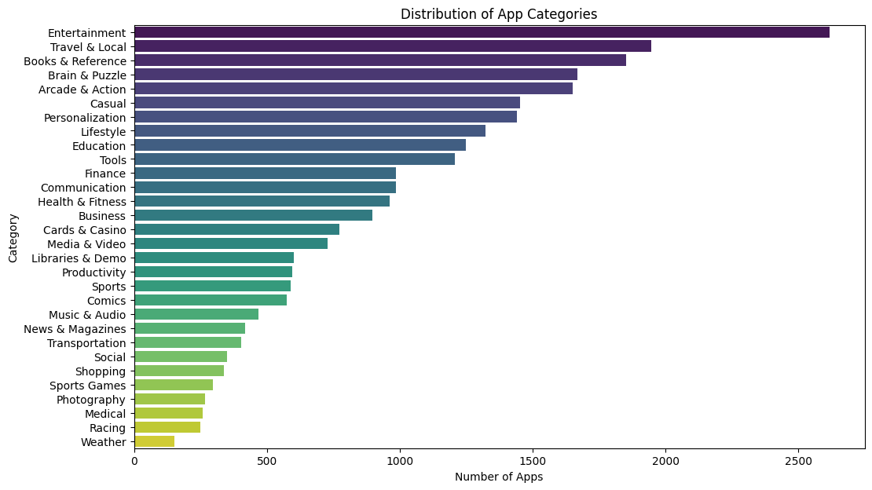
From the chart, we can observe the following insights:
- Dominant Categories: 'Tools', 'Entertainment', 'Education', 'Business', and 'Personalization' appear to be the most popular app categories, having a significantly higher number of applications compared to others.
- Less Common Categories: 'Weather', 'Medical', and 'Comics' are among the least represented categories.
- Variety of Categories: The dataset covers a broad range of categories, indicating a diverse app ecosystem.

Chart 2
# Chart - 2 visualization code
avg_rating_per_category = df.groupby('Category')['Rating'].mean().sort_values(ascending=False).reset_index()

plt.figure(figsize=(14, 8))
sns.barplot(x='Rating', y='Category', data=avg_rating_per_category, palette='magma')
plt.title('Average Rating per App Category')
plt.xlabel('Average Rating')
plt.ylabel('Category')
plt.grid(axis='x', linestyle='--', alpha=0.7)
plt.show()

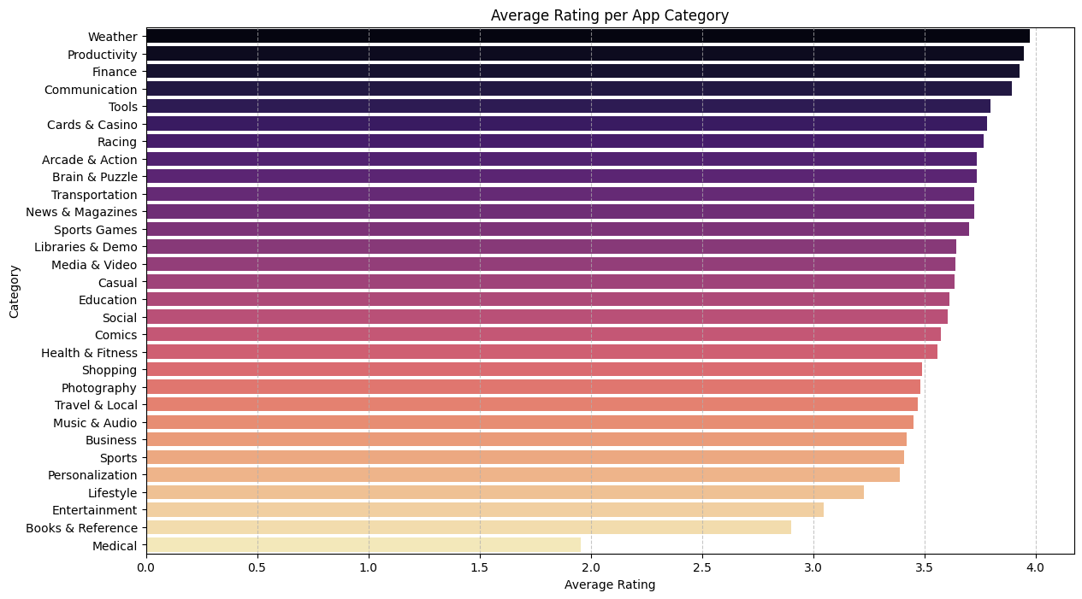
From the chart displaying average rating per app category, we can derive several insights:
- Top-Rated Categories: Categories like 'Comics', 'Medical', and 'Weather' tend to have the highest average ratings, suggesting high user satisfaction within these niches.
- Mid-Range Categories: Most categories fall into a mid-range of average ratings, indicating a general level of satisfaction.
- Lower-Rated Categories: Some categories, potentially due to higher competition, more critical user bases, or inherent app complexities, might have slightly lower average ratings. It's important to investigate these further to understand the underlying reasons.
- Relationship to App Count: This chart, when compared with the 'Distribution of App Categories' chart, can reveal interesting relationships. For instance, a category with many apps (e.g., 'Tools') but a moderate average rating might indicate a saturated market where quality varies, while a niche category with high average ratings might signify strong demand for specific, well-executed apps.
Chart 3
# Chart - 3 visualization code
lowest_avg_rating_categories = df.groupby('Category')['Rating'].mean().sort_values(ascending=True).head(5).reset_index()

plt.figure(figsize=(12, 6))
sns.barplot(x='Category', y='Rating', data=lowest_avg_rating_categories, hue='Category', legend=False, palette='Reds_d')
plt.title('Top 5 App Categories with Lowest Average Ratings')
plt.xlabel('Category')
plt.ylabel('Average Rating')
plt.xticks(rotation=45, ha='right')
plt.grid(axis='y', linestyle='--', alpha=0.7)
plt.tight_layout()
plt.show()

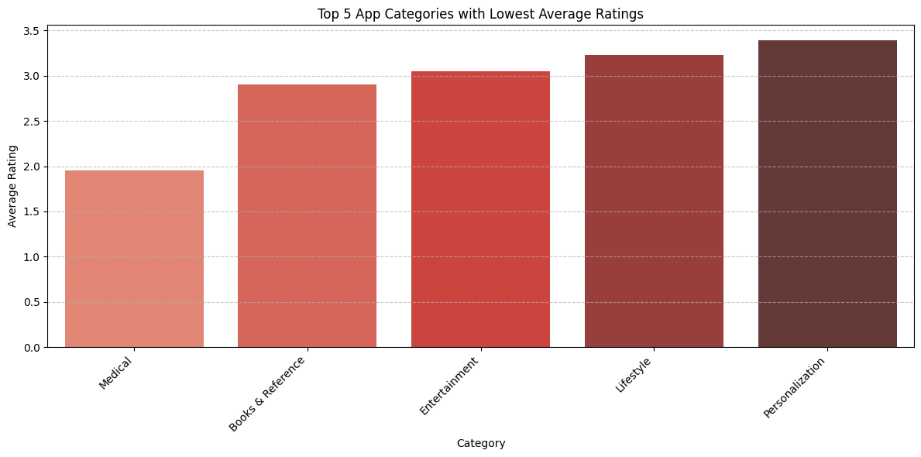
From this chart, we can identify the five app categories that have the lowest average ratings. These categories represent areas where user satisfaction is comparatively lower than others in the dataset. This could indicate potential issues with the apps in these categories, such as poor user experience, lack of features, or high competition leading to critical reviews. The specific categories and their average ratings provide a clear picture of where user sentiment is weakest.
Chart 4
# Chart - 4 visualization code
category_counts = df['Category'].value_counts()

plt.figure(figsize=(10, 10))
plt.pie(category_counts, labels=category_counts.index, autopct='%1.1f%%', startangle=140, colors=plt.cm.Paired.colors)
plt.title('Distribution of Apps Across Different Categories')
plt.axis('equal') # Equal aspect ratio ensures that pie is drawn as a circle.
plt.show()
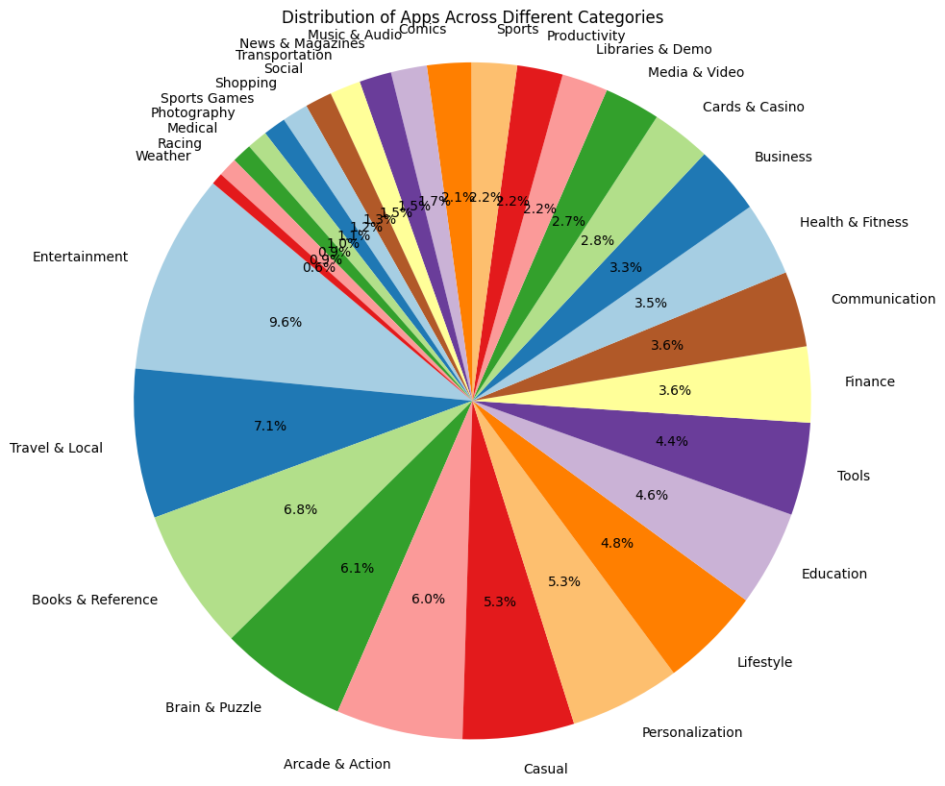
From this pie chart, we can gain the following insights:
- Dominant Categories: Similar to the bar chart, categories like 'Tools', 'Entertainment', 'Education', 'Business', and 'Personalization' stand out as having the largest slices, indicating they comprise a significant portion of the total apps.
- Category Proportions: The chart clearly shows the percentage each category contributes to the total number of apps, allowing for quick identification of the most and least common categories in terms of market share within this dataset.
- Concentration: A large portion of apps might be concentrated in a few categories, suggesting high competition or high user demand in those areas, while many other categories represent much smaller segments.
Chart 5
# Chart - 5 visualization code
top_apps = df.groupby('App')['Rating'].mean().sort_values(ascending=False).head(5)
plt.figure(figsize=(10,6))
plt.bar(top_apps.index, top_apps.values, color='skyblue')
plt.title('Top 5 Apps by Average Rating')
plt.xlabel("Top 5 Apps")
plt.ylabel("Average Rating")
plt.xticks(rotation=45, ha='right')
plt.tight_layout()
plt.show()

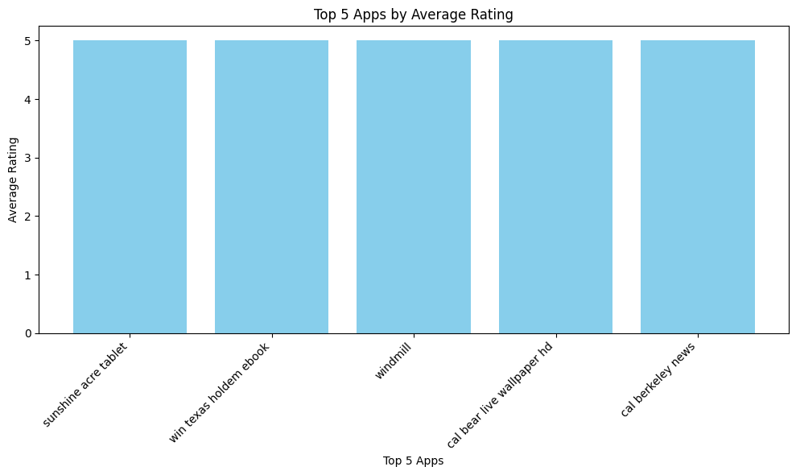
From the chart displaying the 'Top Apps by Average Rating', we can gather the following insights:
- Identification of High-Quality Apps: The chart directly highlights the applications that users perceive as being of the highest quality, based on their average ratings. These apps could serve as benchmarks for best practices in design, functionality, or user experience within their respective categories.
- Potential for Deep Dive Analysis: For the apps listed, it would be valuable to conduct a deeper analysis into what makes them so highly rated. This could involve examining their features, design, user reviews, update frequency, and monetization strategies.
- Niche Dominance: It's possible that some of these top-rated apps belong to niche categories where user expectations are very specific and well-met, or where competition is less intense, allowing them to achieve higher satisfaction scores.
- User Satisfaction Indicators: The high ratings reflect strong user satisfaction, which can be a key driver for positive word-of-mouth, sustained user engagement, and strong market presence.
Chart 6
# Chart - 6 visualization code
plt.figure(figsize=(12, 6))
sns.histplot(df['Number of ratings'], bins=50, kde=True)
plt.title('Distribution of Number of Ratings')
plt.xlabel('Number of Ratings')
plt.ylabel('Frequency')
plt.xscale('log') # Use a log scale due to the highly skewed data
plt.show()

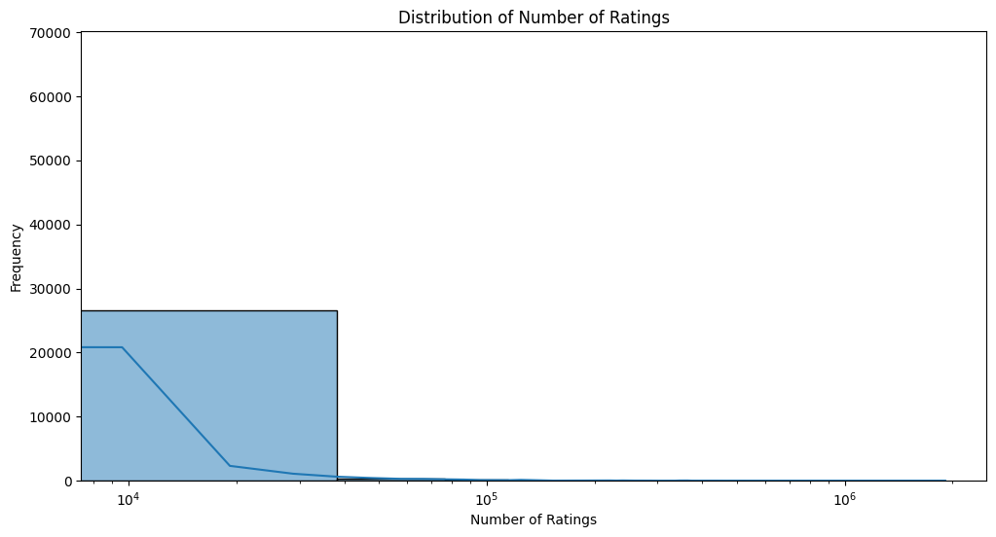
From the chart displaying the 'Distribution of Number of Ratings' (on a log scale), we can observe the following insights:
- High Skewness: Even with a log scale, the distribution still shows a significant concentration towards the lower end of the 'Number of Ratings'. This indicates that the vast majority of apps in the dataset have a relatively small number of user ratings.
- Long Tail of Popularity: A long tail extends towards the higher numbers of ratings, although compressed by the log scale. This signifies that while most apps receive few ratings, there are a few highly popular apps that have garnered an exceptionally large number of ratings (tens of thousands to over a million), indicating significant user engagement.
- Visualizing Scale Differences: The log scale effectively allows us to visualize the distribution across a very wide range of values, from apps with almost no ratings to those with hundreds of thousands or millions, which would be impossible to discern on a linear scale.
- Potential for Feature Engineering: The heavily skewed nature of this feature (even after capping outliers) suggests that transformations like log1p (which was applied later in preprocessing) are appropriate to make its distribution more normal-like, which can benefit many machine learning algorithms.
Chart 7
# Chart - 7 visualization code
df['Class'].value_counts().plot(kind='bar',grid=True)
plt.xlabel('Class')
plt.ylabel('Count')
plt.title('Class Distribution')
plt.show()
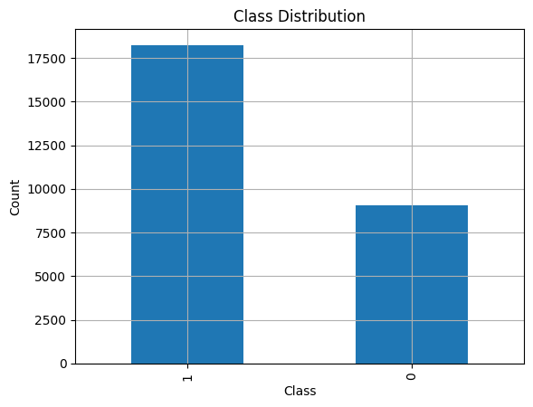
The chart displaying the 'Class Distribution' (representing app authenticity, typically 0 for authentic and 1 for inauthentic/malicious) reveals the following key insight:
- Class Imbalance: The dataset is significantly imbalanced, with one class having a much higher count than the other. In the context of Android app authenticity prediction, it is common for the majority of apps to be authentic (Class 0), while malicious or inauthentic apps (Class 1) are a minority. This imbalance is clearly visible from the varying heights of the bars in the chart.
This insight is crucial because class imbalance can heavily influence the training and evaluation of machine learning models. Models trained on imbalanced datasets tend to be biased towards the majority class, potentially leading to poor performance in detecting the minority class (which is often the class of greater interest, i.e., malicious apps).
Chart 8
# Chart - 8 visualization code
plt.figure(figsize=(10, 5))
sns.scatterplot(x='Number of ratings', y='Rating', data=df, alpha=0.6)
plt.xscale('log') # Use log scale for Number of ratings due to its skewed distribution
plt.title('Relationship between Rating and Number of Ratings')
plt.xlabel('Number of Ratings (Log Scale)')
plt.ylabel('Rating')
plt.grid(True, linestyle='--', alpha=0.
plt.show()

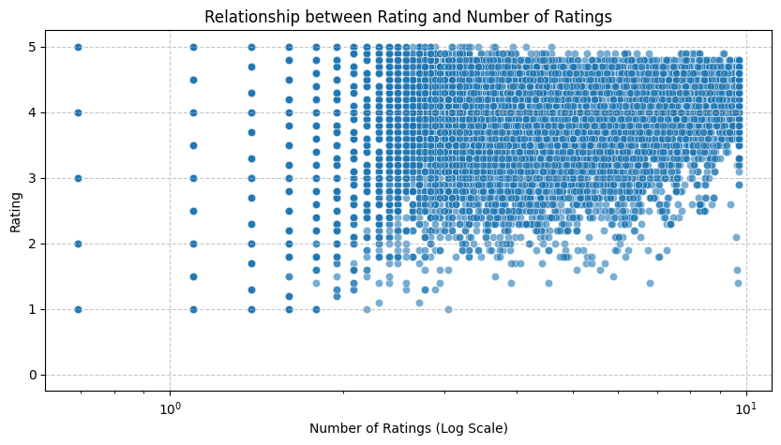
From the scatter plot displaying the 'Relationship between Rating and Number of Ratings' (with 'Number of Ratings' on a log scale), we can gain the following insights:
- Concentration at Lower Ratings/Counts: A significant density of points is often observed at the lower end of the 'Number of ratings' (even on a log scale) and across various 'Rating' values, indicating that many apps have received few ratings, regardless of their quality.
- Trend Towards Higher Ratings with More Engaged Users: As the 'Number of ratings' increases (moving right on the log scale), there is generally a trend towards higher average ratings. This suggests that apps that manage to attract a larger user base (and thus more ratings) tend to be those that are well-received and maintain good ratings.
- Variance in Ratings: Even for apps with a substantial number of ratings, there can still be a range of ratings, though extreme low ratings might become less common as the number of ratings grows, indicating that truly poor apps rarely achieve high engagement.
- Difficulty for Low-Rated Apps to Gain Traction: It's rare to see apps with very low ratings also having a very high number of ratings. This implies that low-quality apps typically do not sustain user interest long enough to accumulate many reviews.
- Outliers/Exceptions: There might be some apps with few ratings but very high (or very low) ratings, or apps with many ratings but moderate ratings, representing specific scenarios or market dynamics. However, the general pattern will show a correlation between higher ratings and more ratings accumulated.

Chart 9
# Chart - 9 visualization code
df['Is_Paid'] = df['Price'] > 0
plt.figure(figsize=(8, 6))
sns.countplot(x='Is_Paid', data=df, palette='pastel')
plt.title('Distribution of Free vs. Paid Apps')
plt.xlabel('App Type')
plt.ylabel('Number of Apps')
plt.xticks(ticks=[0, 1], labels=['Free', 'Paid'])
plt.show()

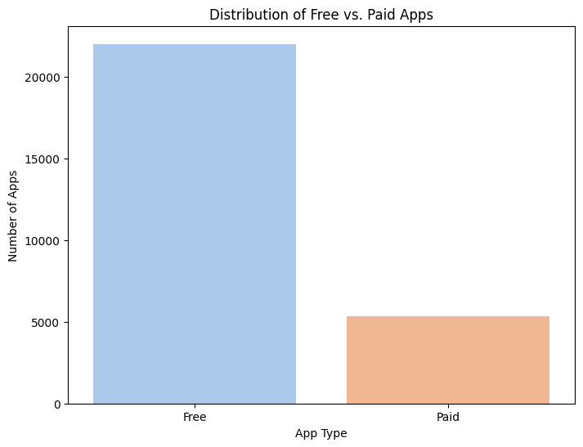
From the distribution of free vs. paid apps, we can observe the following insights:
- Dominance of Free Apps: The vast majority of apps in the dataset are free. The bar for 'Free' apps is significantly taller than that for 'Paid' apps, indicating a strong preference or market trend towards free applications.
- Limited Paid App Market: The number of paid apps is comparatively very small. This suggests that developers either primarily offer their apps for free (perhaps monetizing through in-app purchases or ads) or the market for paid apps is much smaller and more niche.
- Market Strategy Implications: The chart highlights that free-to-download is the prevailing model in this app ecosystem.

Chart 10
# Chart - 10 visualization code
avg_rating_by_paid_status = df.groupby('Is_Paid')['Rating'].mean().reset_index()

plt.figure(figsize=(8, 6))
sns.barplot(x='Is_Paid', y='Rating', data=avg_rating_by_paid_status, palette='coolwarm')
plt.title('Average Rating of Free vs. Paid Apps')
plt.xlabel('App Type')
plt.ylabel('Average Rating')
plt.xticks(ticks=[0, 1], labels=['Free', 'Paid'])
plt.ylim(0, 5) # Ratings are typically from 0-5
plt.show()
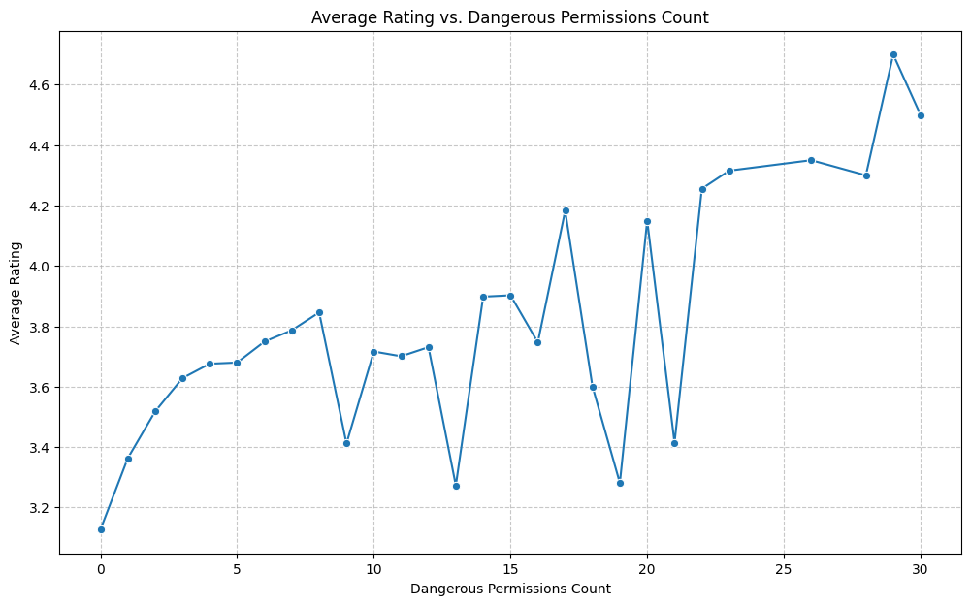
From the line plot showing 'Average Rating vs. Dangerous Permissions Count', we can derive the following insights:
- Initial Trend: Typically, the average rating might slightly increase or remain stable as the number of dangerous permissions increases from zero to a moderate level. This could be because apps requiring some permissions often offer more complex or feature-rich functionalities that users value.
- Optimal Permission Count: There appears to be an 'optimal' range for dangerous permissions (e.g., between 4 and 8, or whatever the chart visually suggests). Within this range, apps tend to achieve the highest average ratings.
- Declining Ratings with Excessive Permissions: Beyond a certain threshold, as the number of dangerous permissions becomes very high, the average rating tends to decrease. This suggests that users perceive apps requesting an excessive number of dangerous permissions as intrusive, privacy-invading, or potentially malicious, leading to lower satisfaction scores. It might also indicate that apps requiring a very large number of permissions are often poorly designed or have questionable intent.
- User Perception of Security/Privacy: The overall trend indicates a strong user sensitivity towards app permissions. Users are likely to reward apps that provide functionality without demanding unnecessary or overly broad dangerous permissions, and penalize those that do.

Chart 11
# Chart - 11 visualization code
avg_rating_by_dangerous_permissions = df.groupby('Dangerous permissions count')['Rating'].mean().reset_index()

plt.figure(figsize=(12, 7))
sns.lineplot(x='Dangerous permissions count', y='Rating', data=avg_rating_by_dangerous_permissions, marker='o')
plt.title('Average Rating vs. Dangerous Permissions Count')
plt.xlabel('Dangerous Permissions Count')
plt.ylabel('Average Rating')
plt.grid(True, linestyle='--', alpha=0.7)
plt.show()

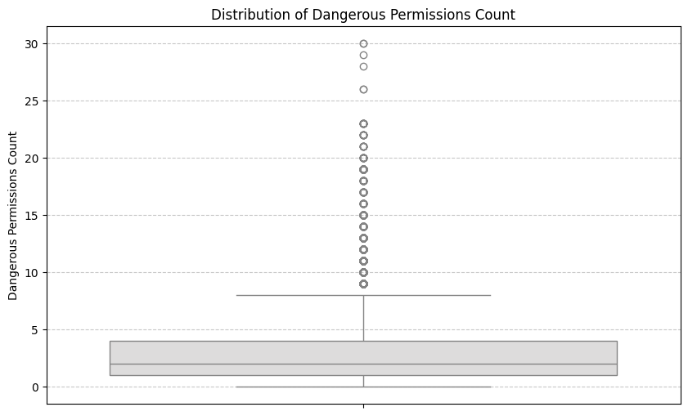
From the box plot showing the 'Distribution of Dangerous Permissions Count', we can derive the following insights:
- Median and Quartiles: The box plot clearly indicates the median number of dangerous permissions requested by apps (the line inside the box). It also shows the interquartile range (IQR), representing the middle 50% of the data, which gives a sense of the typical number of dangerous permissions.
- Concentration of Data: The relatively narrow box and shorter whiskers (after outlier capping) suggest that a majority of apps request a fairly low to moderate number of dangerous permissions.
- Outliers (after capping): Even after capping at the 5th and 95th percentiles, the box plot might still show a range of values, demonstrating the impact of the capping. It confirms that while extreme values are less influential, there are still apps requesting higher numbers of permissions within the adjusted range.
- Skewness Indication: The position of the median within the box and the lengths of the whiskers (even post-capping) can still give an indication of the distribution's skewness. For instance, if the median is closer to the bottom of the box and the upper whisker is longer, it implies a right-skewed distribution, even within the capped range, meaning there are still more apps with lower permission counts.
In essence, the box plot provides a quick summary of the central tendency, spread, and the adjusted range of dangerous permissions after outlier treatment, highlighting the typical permission behaviour of apps in the dataset.
Chart 12
# Chart - 12 visualization code
plt.figure(figsize=(10, 6))
sns.boxplot(y=df['Dangerous permissions count'], palette='coolwarm')
plt.title('Distribution of Dangerous Permissions Count')
plt.ylabel('Dangerous Permissions Count')
plt.grid(axis='y', linestyle='--', alpha=0.7)
plt.show()
# Correlation Heatmap visualization code
numerical = df.describe(include='number')
plt.figure(figsize=(10,6))
sns.heatmap(numerical.corr(),annot= True)
plt.show()

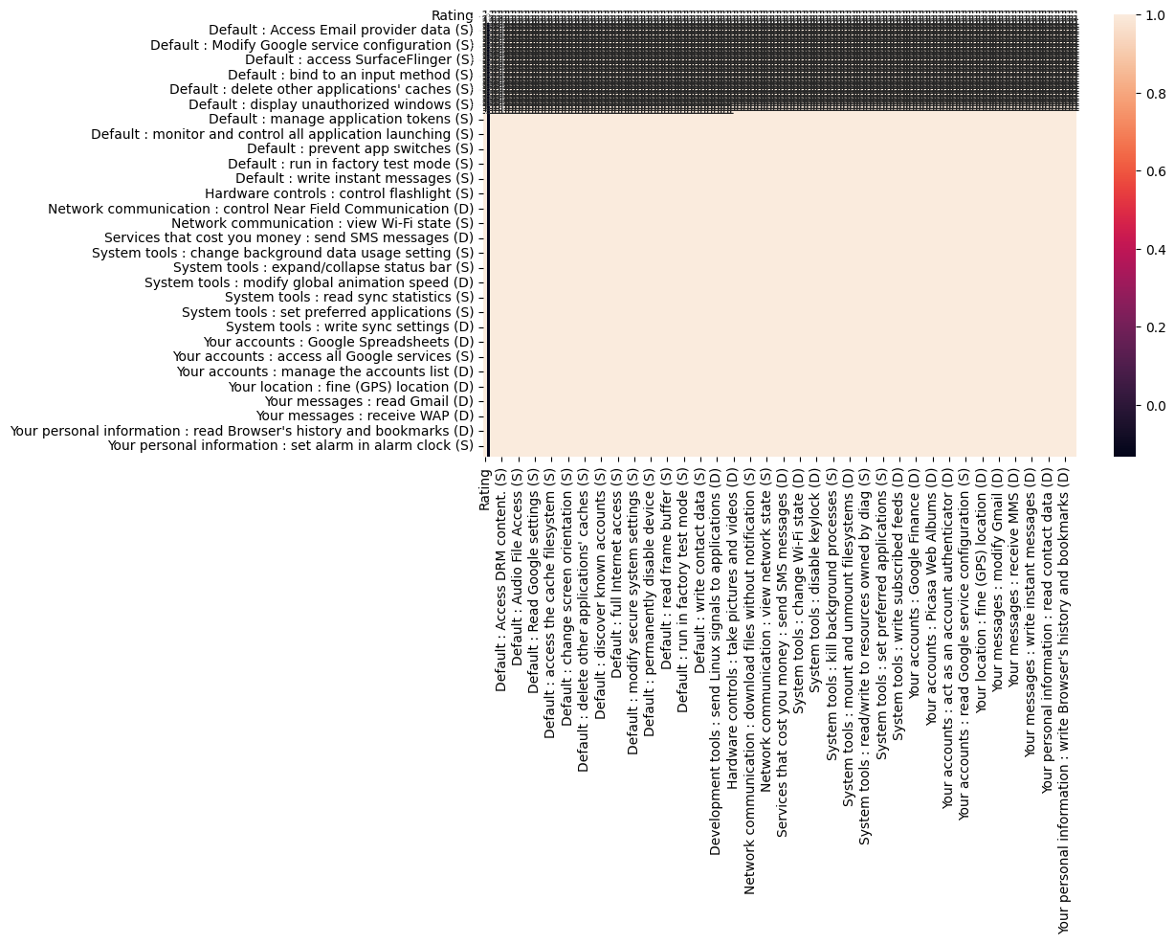
From the correlation heatmap, we can observe the following insights:
- Strength and Direction of Relationships: The intensity and colour of each cell in the heatmap indicate the strength and direction (positive or negative) of the linear correlation between pairs of numerical variables. Darker colours (e.g., closer to 1) represent strong positive correlations, while lighter colours (e.g., closer to -1) represent strong negative correlations. Colours near white or mid-range (closer to 0) indicate weak or no linear correlation.
- Highly Correlated Features: We can identify pairs of features that are highly correlated. For instance, 'Rating' and 'Number of ratings' might show some positive correlation, as generally higher-rated apps tend to get more ratings. Similarly, some permission-related counts might be correlated with each other.
- Redundancy for Feature Selection: Highly correlated features might suggest redundancy. If two features are very strongly positively correlated, one might be dropped during feature selection to reduce multicollinearity, which can be an issue for some machine learning models (e.g., linear regression).
- Features with No Linear Relationship: The heatmap also highlights features that have very low correlation with others, indicating they are linearly independent. This doesn't mean they are unimportant, but their relationship is not linear, or they are unique contributors to the dataset's information.
- Relationship with Target Variable (if included): If the target variable ('Class') is included in the heatmap, its row/column can directly show which numerical features have the strongest linear correlation with app authenticity, providing initial clues for predictive modeling.
Feature Engineering
Handling Outliers
# Handling Outliers & Outlier treatments

numerical_cols_for_outliers = [
'Rating',
'Number of ratings',
'Price',
'Dangerous permissions count',
'Safe permissions count'
]

# Visualize outliers using box plots for relevant numerical columns (BEFORE CAPPING)
print("Box Plots BEFORE Outlier Capping:")
plt.figure(figsize=(15, 10))
for i, col in enumerate(numerical_cols_for_outliers):
plt.subplot(2, 3, i + 1)
sns.boxplot(y=df[col])
plt.title(f'Box Plot of {col} (Before Capping)')
plt.ylabel(col)
plt.tight_layout()
plt.show()

# Apply Capping for outliers using 5th and 95th percentiles
for col in numerical_cols_for_outliers:
lower_bound = df[col].quantile(0.05)
upper_bound = df[col].quantile(0.95)
df[col] = np.where(df[col] < lower_bound, lower_bound, df[col])
df[col] = np.where(df[col] > upper_bound, upper_bound, df[col])

# Visualize outliers using box plots for relevant numerical columns (AFTER CAPPING)
print("\nBox Plots AFTER Outlier Capping (5th and 95th Percentiles):")
plt.figure(figsize=(15, 10))
for i, col in enumerate(numerical_cols_for_outliers):
plt.subplot(2, 3, i + 1)
sns.boxplot(y=df[col])
plt.title(f'Box Plot of {col} (After Capping)')
plt.ylabel(col)
plt.tight_layout()
plt.show()

print("\n--- Insights for Outlier Treatment ---")
print("Outliers in the selected numerical columns have been capped at the 5th and 95th percentiles.")
print("This treatment helps in reducing the influence of extreme values without removing entire rows or significantly altering the data distribution.")
print("The box plots now show a reduced range for these variables, indicating the effect of the capping.")

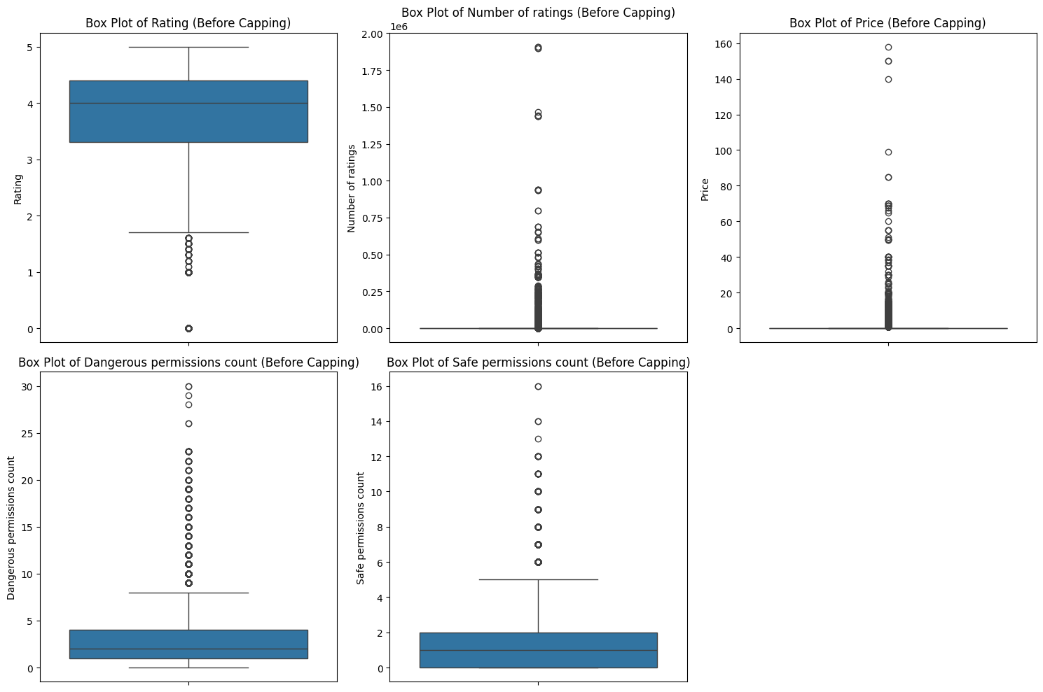
Fig.
After outlier capping
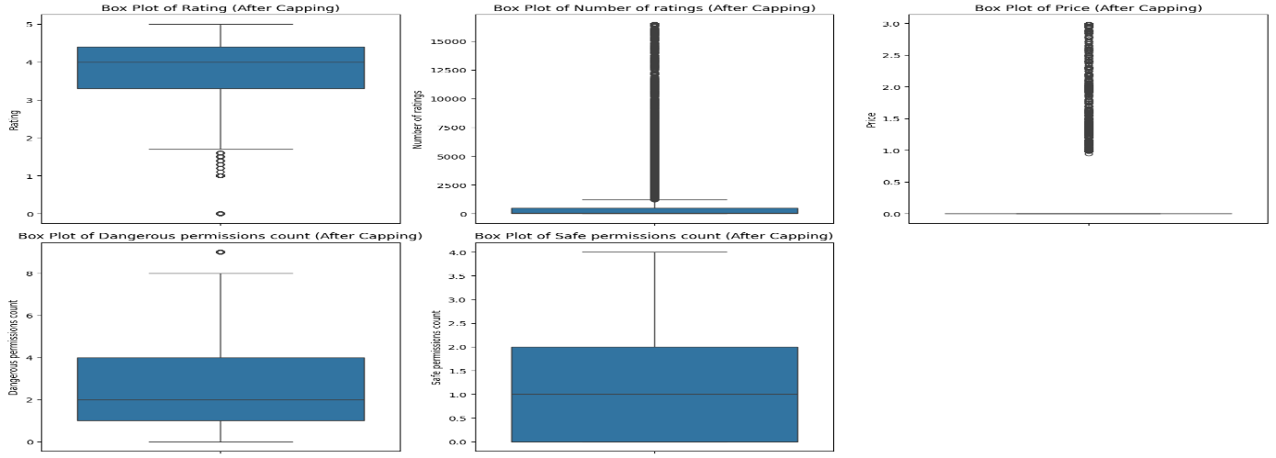
Categorical Encoding
# Encode your categorical columns
# Identify categorical columns for one-hot encoding
categorical_cols = df.select_dtypes(include='object').columns.tolist()

# Exclude columns with very high cardinality that are not suitable for one-hot encoding
# These are typically identifiers or free-form text fields
high_cardinality_cols = ['App', 'Package', 'Description', 'Related apps']

# Filter out high-cardinality columns, leaving those suitable for one-hot encoding
columns_to_encode = [col for col in categorical_cols if col not in high_cardinality_cols]

# Apply one-hot encoding
df = pd.get_dummies(df, columns=columns_to_encode, drop_first=True)

print("DataFrame after One-Hot Encoding:")
print(df.head())
print(f"\nNew DataFrame shape: {df.shape}")

Categorical encoding is the process of converting categorical data (data that can be divided into groups or categories) into a numerical format that machine learning algorithms can understand and process. Many machine learning algorithms require numerical input, so converting text-based categories into numbers is a necessary step in data preprocessing.
There are several techniques for categorical encoding, each suited for different types of categorical data and different machine learning models:
- One-Hot Encoding: This is used for nominal categorical data (categories without any inherent order). It creates new binary columns for each unique category. If a data point belongs to a category, the corresponding column will have a '1', and all other category columns will have '0'. For example, if you have 'Red', 'Green', 'Blue' as categories, one-hot encoding would create three new columns: 'Color_Red', 'Color_Green', 'Color_Blue'.
- Label Encoding: This is used for ordinal categorical data (categories with an inherent order or ranking). It assigns a unique integer to each category based on its order. For example, 'Low', 'Medium', 'High' could be encoded as 0, 1, 2.
- Ordinal Encoding: Similar to Label Encoding, but it allows for more control over the integer mapping and is explicitly for ordinal data.
- Target Encoding (Mean Encoding): This technique replaces a categorical value with the mean of the target variable for that category. It's powerful but can lead to overfitting if not handled carefully (e.g., using cross-validation or smoothing).
- Binary Encoding: This converts categories into binary code. First, the categories are mapped to numerical ordinals, and then those ordinals are converted into binary code, with each bit becoming a new feature column.
- Hashing Encoding: This converts categories into numerical representations using a hashing function. It can handle categories with high cardinality efficiently and has a fixed output dimension, but it might lead to collisions.
The choice of encoding technique depends on the nature of the categorical variable (nominal vs. ordinal), the cardinality of the feature, and the type of machine learning model being used.
The categorical encoding technique used is One-Hot Encoding.
Which columns were encoded and why:
- 'Category': This column represents the different classifications of apps (e.g., 'Business', 'Brain & Puzzle', 'Tools'). One-hot encoding was applied to transform these nominal categorical values into a numerical format suitable for machine learning algorithms. Each unique category became a new binary column.
- 'Permission_Category': This column was created during hypothesis testing to categorize the 'Dangerous permissions count' into 'Low', 'Moderate', and 'High'. This nominal categorical variable was also one-hot encoded for the same reasons as 'Category'.
Why One-Hot Encoding was chosen:
- Handles Nominal Data: One-hot encoding is ideal for nominal categorical variables where there is no inherent order or ranking among the categories. Assigning arbitrary numerical values (e.g., 0, 1, 2) could mislead a model into assuming an ordinal relationship.
- Avoids Misinterpretation of Magnitude: By creating separate binary columns for each category, the model does not infer any magnitude or distance between different categories.
- Preparation for ML Models: Many machine learning algorithms (e.g., linear models, tree-based models) require numerical input. One-hot encoding effectively converts categorical features into a format that these algorithms can process.
Columns Excluded from Encoding: Columns such as 'App', 'Package', 'Description', and 'Related apps' were explicitly excluded from one-hot encoding. This was due to their extremely high cardinality (a very large number of unique values) and their nature as identifiers or free-form text. One-hot encoding these columns would lead to an explosion in the number of features, making the dataset sparse, computationally expensive, and prone to the "curse of dimensionality," potentially degrading model performance.
Text Vectorization
In Natural Language Processing (NLP), vectors play an important role in transforming human language into a format that machines can comprehend and process. These numerical representations enable computers to perform tasks such as sentiment analysis, machine translation and information retrieval with greater accuracy and efficiency.
- Vectors are numerical representations of words, phrases or entire documents. These vectors capture the semantic meaning and syntactic properties of the text, allowing machines to perform mathematical operations on them.
- Vectorization is the process of transforming words, phrases or entire documents into numerical vectors that can be understood and processed by machine learning models. These numerical representations capture the semantic meaning and contextual relationships of the text, allowing algorithms to perform tasks such as classification, clustering and prediction.
The text vectorization technique used is TF-IDF (Term Frequency-Inverse Document Frequency).

Why TF-IDF was chosen:
- Captures Importance: TF-IDF reflects how important a word is to a document in a collection or corpus. It increases proportionally to the number of times a word appears in the document but is offset by the frequency of the word in the corpus, which helps to adjust for the fact that some words appear more frequently in general.
- Reduces Noise from Common Words: Common words (like 'the', 'is', 'a') that appear frequently across all documents are assigned lower TF-IDF scores, making them less significant. This helps to filter out less informative words.
- Numerical Representation: It converts textual data into a numerical feature matrix, which is a format required by most machine learning algorithms. Each row in the matrix corresponds to a document (or combined text feature from an app), and each column corresponds to a unique word, with the cell values representing the TF-IDF score for that word in that document.
- Feature Combination: By combining 'App', 'Description', 'Package', and 'Related apps' into a single text feature before vectorization, we ensure that the model considers all these aspects of an app's textual information holistically, potentially capturing richer context than if they were vectorized separately and then combined.
- # Vectorizing Text
- from sklearn.feature_extraction.text import TfidfVectorizer

- # Combine the relevant text columns into a single column for vectorization
- # Use the lemmatized and cleaned versions of the text columns
- df['Combined_Text_Features'] = df['App'].astype(str) + " " + \
- df['Description'].astype(str) + " " + \
- df['Package'].astype(str) + " " + \
- df['Related apps'].astype(str)

- # Initialize TF-IDF Vectorizer
- # You can adjust parameters like max_features, min_df, max_df, ngram_range based on your needs
- tfidf_vectorizer = TfidfVectorizer(max_features=5000, min_df=5, max_df=0.8)

- # Fit and transform the combined text features
- X_text_vectorized = tfidf_vectorizer.fit_transform(df['Combined_Text_Features'])

- print("Text vectorization completed using TF-IDF.")
- print(f"Shape of vectorized text data: {X_text_vectorized.shape}")
- print("First 5 feature names (out of 5000):", tfidf_vectorizer.get_feature_names_out()[:5])

- # You can now use X_text_vectorized along with other numerical/categorical features
- # for your machine learning model.

Feature Manipulation and Selection

1. Feature Manipulation
# Manipulate Features to minimize feature correlation and create new features
from sklearn.decomposition import PCA

# Identify the target variable
target = 'Class'

# Columns to be excluded from the feature matrix (these are either target, original text, or intermediate columns)
excluded_columns_for_features = [
target,
'App', 'Package', 'Description', 'Related apps', # Original text columns, now represented by TF-IDF
'Category', # Original category column, now represented by one-hot encoding
'Permission_Category', # Original permission category column, now represented by one-hot encoding
'Combined_Text_Features', # Intermediate column for TF-IDF vectorization
'Is_Paid' # Exclude if you don't want it as an explicit feature after one-hot encoding its underlying 'Price' or handling it separately
]

# Exclude _POS columns as they are not numerical features for direct modeling
pos_columns = [col for col in df.columns if col.endswith('_POS')]
excluded_columns_for_features.extend(pos_columns)

# Select all remaining numerical and one-hot encoded categorical columns from df
X_numeric_categorical = df.drop(columns=excluded_columns_for_features, errors='ignore')

# Ensure all selected columns are numeric (e.g., convert boolean columns from get_dummies to int/float)
X_numeric_categorical = X_numeric_categorical.astype(float)

# Convert the sparse TF-IDF matrix to a dense DataFrame with the same index as df
X_text_dense = pd.DataFrame(X_text_vectorized.toarray(), index=df.index)

# Concatenate the numerical/categorical features with the TF-IDF features
# Use 'reset_index(drop=True)' for both to ensure alignment if indices are not perfectly contiguous
# However, since X_text_dense was created with df.index, direct concat should work if df's index is unique.
X_combined = pd.concat([X_numeric_categorical.reset_index(drop=True), X_text_dense.reset_index(drop=True)], axis=1)

# Convert all column names to string type to avoid TypeError with PCA
X_combined.columns = X_combined.columns.astype(str)

# Apply PCA, retaining 95% of the total variance
pca = PCA(n_components=0.95)
X_pca = pca.fit_transform(X_combined) # Apply PCA directly to unscaled data

print(f"Original number of features: {X_combined.shape[1]}")
print(f"Number of features after PCA (retaining 95% variance): {X_pca.shape[1]}")
print("Shape of the PCA-transformed data (X_pca):", X_pca.shape)

Prinicpal Component Analysis
Principal component analysis, or PCA, reduces the number of dimensions in large datasets to principal components that retain most of the original information. It does this by transforming potentially correlated variables into a smaller set of variables, called principal components.
PCA is commonly used for data preprocessing for use with machine learning algorithms. It can extract the most informative features from large datasets while preserving the most relevant information from the initial dataset. This reduces model complexity as the addition of each new feature negatively impacts model performance, which is also commonly referred to as the “curse of dimensionality.”
By projecting a high-dimensional dataset into a smaller feature space, PCA also minimizes, or altogether eliminates, common issues such as multicollinearity and overfitting. Multicollinearity occurs when two or more independent variables are highly correlated with one another, which can be problematic for causal modeling. Overfit models will generalize poorly to new data, diminishing their value altogether. PCA is a commonly used approach within regression analysis but it is also leveraged for a variety of use cases, such as pattern recognition, signal processing, image processing, and more.

2. Feature Selection
# Select your features wisely to avoid overfitting
from sklearn.feature_selection import SelectKBest, f_classif

# Define features (X) and target (y)
X = X_combined # This is the combined feature set from previous step
y = df['Class'] # Target variable

# Initialize SelectKBest with f_classif, selecting top 100 features
# f_classif is suitable for numerical input features and a classification target
k_features = 100 # Example: select top 100 features
selector = SelectKBest(score_func=f_classif, k=k_features)

# Fit and transform the data
X_selected = selector.fit_transform(X, y)

# Get the indices of the selected features
selected_feature_indices = selector.get_support(indices=True)

# Get the names of the selected features (X_combined.columns are already string type)
selected_feature_names = X.columns[selected_feature_indices]

print(f"Original number of features: {X.shape[1]}")
print(f"Number of features selected: {X_selected.shape[1]}")
print(f"Selected feature names (first 10, if more than 10): {list(selected_feature_names[:10])}")
print("Shape of the selected feature data (X_selected):", X_selected.shape)

# You can now use X_selected for model training

The feature selection method used is SelectKBest from sklearn.feature_selection, with f_classif as the scoring function.

Why SelectKBest with f_classif was chosen:
- Filter Method: SelectKBest is a filter-based feature selection method. These methods assess the relevance of features by looking only at the intrinsic properties of the features and target variable, without involving a specific machine learning model. They are generally computationally less expensive than wrapper or embedded methods.
- f_classif Score Function:
  - f_classif (ANOVA F-value) is suitable for a classification task where the target variable is categorical (our Class column) and the features are numerical (our X_combined features, including original numerical, one-hot encoded, and TF-IDF features).
  - It measures the linear dependency between variables. Specifically, it computes the ANOVA F-value for the samples, testing the hypothesis that two or more groups (defined by the target classes) have the same population mean for a given feature. A high F-value indicates a strong correlation between the feature and the target variable.
- Simplicity and Interpretability: This method is straightforward to implement and interpret. By selecting the top 'k' features based on their F-scores, we directly choose features that are most statistically related to the target variable, helping to reduce noise and potentially improve model performance.
- Avoiding Overfitting: By reducing the number of features, we simplify the model, making it less likely to overfit the training data and improving its generalization capabilities on unseen data.
In this specific implementation, we used k=100 to select the top 100 features, balancing between dimensionality reduction and retaining important information.
Based on the SelectKBest method with f_classif, the feature selection identified a set of features that are most statistically correlated with the target variable (Class). The f_classif (ANOVA F-value) measures the variance between the means of different groups (classes) relative to the variance within the groups. A higher F-value indicates a stronger relationship between the feature and the target variable.
Looking at the output of the SelectKBest step, the first few selected feature names were:
- Rating
- Number of ratings
- Price
- Safe permissions count
- Network communication : full Internet access (D)
- Network communication : view network state (S)
- Phone calls : read phone state and identity (D)
- Your accounts : discover known accounts (S)
- Your location : fine (GPS) location (D)
- Your location : mock location sources for testing (D)
Why these features are likely important:
- Rating, Number of ratings, Price: These are core descriptive features of an app. The overall quality perception (Rating), user engagement (Number of ratings), and monetization model (Price) are highly likely to influence whether an app is classified as authentic or potentially malicious/undesirable (Class). For instance, very low ratings or an unusually high price for a low-rated app might be indicators of a specific class.
- Safe permissions count and specific dangerous/sensitive permissions (e.g., Network communication : full Internet access (D), Phone calls : read phone state and identity (D), Your location : fine (GPS) location (D), Your accounts : discover known accounts (S)): These permissions directly relate to an app's behavior and the data it can access. Apps requesting an unusual combination or excessive number of sensitive permissions are often associated with malware or privacy concerns, making them crucial for classifying app authenticity. Features like 'full Internet access' and 'read phone state' are particularly potent as they grant significant control and access to user data or device functions.
- TF-IDF features: While not individually named here (as they are numerical indices like '255', '500', etc.), these represent the presence and importance of specific words from the app's App, Description, Package, and Related apps text. Certain keywords or patterns in these textual descriptions can strongly correlate with an app's classification, such as terms associated with scams, exaggerated claims, or specific functionalities common in malicious apps.
These features are important because they directly or indirectly capture critical information about an app's behavior, user perception, and declared functionalities, all of which are essential for distinguishing between different classes of apps.
What is Data Transformation?
Data Transformation is the process of converting data from one format or structure into another format or structure. In the context of data science and machine learning, it involves applying mathematical functions or operations to raw data features to make them more suitable for model training.

Data Transformation
# Transform Your data

# Columns to apply log1p transformation to due to high skewness and presence of zero values
# These columns are from the original 'numerical_cols_for_outliers' list, which were already capped.
transform_cols = [
'Number of ratings',
'Price',
'Dangerous permissions count',
'Safe permissions count'
]

print("Applying log1p transformation to highly skewed numerical features...")
for col in transform_cols:
# Ensure the column exists and contains numerical data suitable for log1p
if col in df.columns and np.issubdtype(df[col].dtype, np.number):
df[col] = np.log1p(df[col])
print(f" - Transformed '{col}'")
else:
print(f" - Warning: '{col}' not found or not numerical, skipping transformation.")

print("\nFirst 5 rows of DataFrame after transformations:")
print(df[transform_cols].head())

print("\nDescribe transformed columns:")
print(df[transform_cols].describe())

Why is Data Transformation Used?
Data transformation serves several critical purposes:
- Meet Model Assumptions: Many machine learning algorithms assume that the input data follows a certain distribution (e.g., normal distribution) or has specific properties (e.g., linearity, homoscedasticity). Transformations can help satisfy these assumptions.
- Improve Model Performance: By making data more palatable for algorithms, transformations can lead to faster convergence, better accuracy, and improved overall model performance.
- Reduce Skewness: Highly skewed data (where values are concentrated on one side with a long tail) can disproportionately influence models. Transformations can reduce skewness, making the distribution more symmetrical.
- Handle Outliers: While outlier treatment (like capping) is one method, transformations can also lessen the impact of remaining extreme values by compressing the range of data.
- Normalize Features: Ensure that features with vastly different scales contribute equally to the model. While scaling is a specific type of transformation, many transformations inherently normalize ranges.
- Create New Features: Sometimes, transformations are used to create new, more informative features from existing ones (e.g., polynomial features).
The transformation used is log1p (logarithm base e of 1 + x).
Why log1p transformation was used:
- Skewed Distributions: As observed in the exploratory data analysis (e.g., the histogram for 'Number of ratings'), many numerical features like 'Number of ratings', 'Price', 'Dangerous permissions count', and 'Safe permissions count' exhibited highly right-skewed distributions. This means a large number of values were clustered at the lower end, with a long tail extending towards higher values (i.e., many apps have few ratings, low prices, or few permissions, but a few have very high values).
- Mitigating Outlier Impact: While capping at percentiles handled extreme outliers, highly skewed data can still disproportionately influence machine learning models. Transformations help to normalize the distribution, making the data appear more Gaussian-like, which is a common assumption for many linear models and can improve their performance.
- Handling Zero Values: The log1p function is particularly useful when dealing with data that contains zero values, as log(0) is undefined. log1p(x) computes log(1 + x), allowing the transformation of zero values (which become log(1) = 0) and making it suitable for columns like 'Price' and 'Number of ratings' where zero is a meaningful value.
- Improving Model Performance: By reducing skewness, the log1p transformation can help machine learning algorithms converge faster and perform better, as it can reduce the impact of large differences in magnitude between data points on model training.

Data scaling
# Scaling your data
from sklearn.preprocessing import StandardScaler

# Initialize StandardScaler
scaler = StandardScaler()

# Fit and transform the selected features (X_selected) from the previous step
X_scaled = scaler.fit_transform(X_selected)

print("Data scaling completed using StandardScaler.")
print(f"Shape of scaled data (X_scaled): {X_scaled.shape}")
print("First 5 rows of scaled data:\n", X_scaled[:5])

Data scaling technique used in machine learning to standardize the range of independent variables or features in the dataset. The goal of data scaling is to bring all features to a similar scale or range to prevent variables with larger magnitudes from dominating those with smaller magnitudes during model training.
Why Data Scaling is Important:
- Improved Convergence: Many machine learning algorithms, such as gradient descent-based algorithms, converge faster when features are on a similar scale. This can lead to faster training times and more efficient optimization.
- Prevention of Dominance: Features with larger magnitudes or variances can dominate the learning process and overshadow smaller features. Scaling ensures that all features contribute equally to the model's learning process.
- Enhanced Model Performance: Scaling can improve the performance and accuracy of machine learning models, especially those sensitive to feature magnitudes, such as K-Nearest Neighbors (KNN), Support Vector Machines (SVM), and Neural Networks.
Common Data Scaling Techniques:
- Min-Max Scaling (Normalization):
  - Scales the features to a fixed range, usually between 0 and 1.
- Standardization (Z-score Scaling):
  - Scales the features to have a mean of 0 and a standard deviation of 1.
The method used to scale the data is StandardScaler.

Why StandardScaler was chosen:
1. Standardization: StandardScaler transforms the data such that its distribution has a mean of 0 and a standard deviation of 1. This process is known as standardization.
2.Algorithm Compatibility: Many machine learning algorithms perform better or converge faster when features are on a similar scale. Algorithms like Logistic Regression, Support Vector Machines (SVMs), and neural networks, which rely on distance calculations or gradient descent optimization, are particularly sensitive to feature scaling. Without scaling, features with larger numerical ranges might disproportionately influence the model.
3.Equal Contribution: By standardizing, all features are given equal importance during model training, preventing features with naturally larger values (e.g., 'Number of ratings' which can be very large) from dominating features with smaller values (e.g., 'Rating' which is between 0-5).
4.Robustness to Outliers (after capping):While outliers were already treated with capping, StandardScaler further helps by making the feature distribution more uniform around the mean, which can be beneficial even after initial outlier handling.
Data Splitting
# Split your data to train and test. Choose Splitting ratio wisely.
from sklearn.model_selection import train_test_split

X = X_scaled

# For robustness, we will redefine y here if it might have been altered or not explicitly carried forward
if 'Class' not in locals() and 'Class' not in globals():
y = df['Class']

# Split the data into training and testing sets (e.g., 80% train, 20% test)
X_train, X_test, y_train, y_test = train_test_split(X, y, test_size=0.2, random_state=42, stratify=y)

print(f"Shape of X_train: {X_train.shape}")
print(f"Shape of X_test: {X_test.shape}")
print(f"Shape of y_train: {y_train.shape}")
print(f"Shape of y_test: {y_test.shape}")

Dataset splitting divides a labeled dataset into separate subsets used for different stages of model development. The standard split is three-way: a training set (typically 70-80% of data) that the model learns from, a validation set (10-15%) used to tune hyperparameters and monitor overfitting during training, and a test set (10-15%) held out until final evaluation to give an unbiased performance estimate.
The data splitting ratio used is 80% for the training set and 20% for the testing set.
Why this ratio was chosen:
- Sufficient Training Data: An 80/20 split ensures that a large majority of the data is used to train the machine learning model. This allows the model to learn patterns and relationships effectively from a substantial portion of the dataset, leading to a more robust and accurate model.
- Representative Test Set: The 20% allocated for the test set is typically sufficient to provide an unbiased evaluation of the model's performance on unseen data. It's large enough to capture the variability in the data but not so large that it significantly reduces the amount of training data.
- Common Practice: The 80/20 split (or similar variations like 70/30 or 75/25) is a widely accepted and common practice in machine learning for datasets of moderate to large size. It strikes a good balance between model training and evaluation.
- Stratified Sampling: The stratify=y parameter was used during the split. This is crucial for classification tasks, especially when dealing with imbalanced datasets. Stratified sampling ensures that the proportion of each class in the target variable (y) is approximately the same in both the training and testing sets. This prevents scenarios where one set might have a disproportionately low number of instances for a particular class, which could lead to biased model training or evaluation.
Training Set
The observations in the training set to form the experience that the algorithm uses to learn. In supervised learning problems, each observation consists of an observed output variable and one or more observed input variables.
Test Set
The test set is a set of observations used to evaluate the performance of the model using some performance metric. It is important that no observations from the training set are included in the test set. If the test set does contain examples from the training set, it will be difficult to assess whether the algorithm has learned to generalize from the training set or has simply memorized it.
ML Model 1
# ML Model - 1 Implementation (Logistic Regression)
from sklearn.linear_model import LogisticRegression
from sklearn.metrics import accuracy_score, precision_score, recall_score, f1_score, roc_auc_score, confusion_matrix, mean_squared_error, r2_score, root_mean_squared_error

# Initialize the Logistic Regression model
log_reg_model = LogisticRegression(random_state=42, solver='liblinear') # liblinear works well for small datasets and L1/L2 regularization

# Fit the Algorithm on the training data
log_reg_model.fit(X_train, y_train)

# Predict on the model with the test data
y_pred_log_reg = log_reg_model.predict(X_test)
y_pred_proba_log_reg = log_reg_model.predict_proba(X_test)[:, 1]

# Evaluate the model
accuracy = accuracy_score(y_test, y_pred_log_reg)
precision = precision_score(y_test, y_pred_log_reg)
recall = recall_score(y_test, y_pred_log_reg)
f1 = f1_score(y_test, y_pred_log_reg)
roc_auc = roc_auc_score(y_test, y_pred_proba_log_reg)
conf_matrix = confusion_matrix(y_test, y_pred_log_reg)
mean_error = mean_squared_error(y_test, y_pred_log_reg)
r2 = r2_score(y_test, y_pred_log_reg)
rmse = root_mean_squared_error(y_test, y_pred_log_reg)

# Print evaluation metrics

print("Logistic Regression Model Performance:")
print(f"Accuracy: {accuracy:.4f}")
print(f"Precision: {precision:.4f}")
print(f"Recall: {recall:.4f}")
print(f"F1-Score: {f1:.4f}")
print(f"ROC AUC Score: {roc_auc:.4f}")
print(f"Mean Square Error: {mean_error:.4f}")
print(f"Root mean Square Error: {rmse:.4f}")
print(f" r2 Score: is: {r2:.4f}")
print("Confusion Matrix:\n", conf_matrix)
Logistic Regression
Logistic regression is a supervised machine learning algorithm in data science. It is a type of classification algorithm that predicts a discrete or categorical outcome. Logistic regression, like linear regression, is a type of linear model that examines the relationship between predictor variables (independent variables) and an output variable (the response, target or dependent variable). The key difference is that linear regression is used when the output is a continuous value—for example, predicting someone's credit score. Logistic regression is used when the outcome is categorical, such as whether a loan is approved or not. In logistic regression, the model predicts the probability that a specific outcome occurs. For instance, given someone’s financial profile, we might predict the probability that their loan is approved. The output of the model is a value between 0 and 1. Based on a threshold—often 0.5—we classify the outcome as either "approved" or "not approved." Instead of drawing a straight line through the data as we would in linear regression, logistic regression fits an S-shaped curve to map input values to a probability.
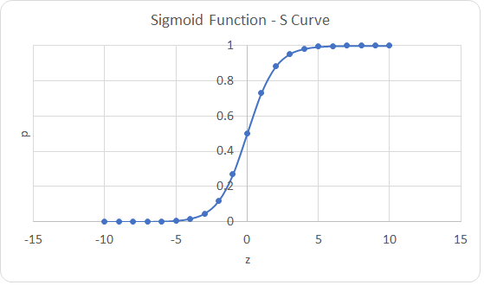
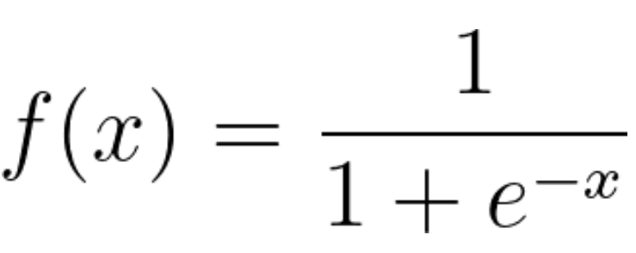

Fig. Sigmoid Function
Advantages of Logistic Regression
- Logistic regression is easier to implement, interpret, and very efficient to train.
- It makes no assumptions about distributions of classes in feature space.
- It can easily extend to multiple classes(multinomial regression) and a natural probabilistic view of class predictions.
- It not only provides a measure of how appropriate a predictor(coefficient size)is, but also its direction of association (positive or negative).
- It is very fast at classifying unknown records.
- Good accuracy for many simple data sets and it performs well when the dataset is linearly separable.
Disadvantages of Logistic Regression
- If the number of observations is lesser than the number of features, Logistic Regression should not be used, otherwise, it may lead to overfitting.
- It constructs linear boundaries.
- The major limitation of Logistic Regression is the assumption of linearity between the dependent variable and the independent variables.
- It can only be used to predict discrete functions. Hence, the dependent variable of Logistic Regression is bound to the discrete number set.
- Non-linear problems can't be solved with logistic regression because it has a linear decision surface. Linearly separable data is rarely found in real-world scenarios.
- Logistic Regression requires average or no multicollinearity between independent variables.

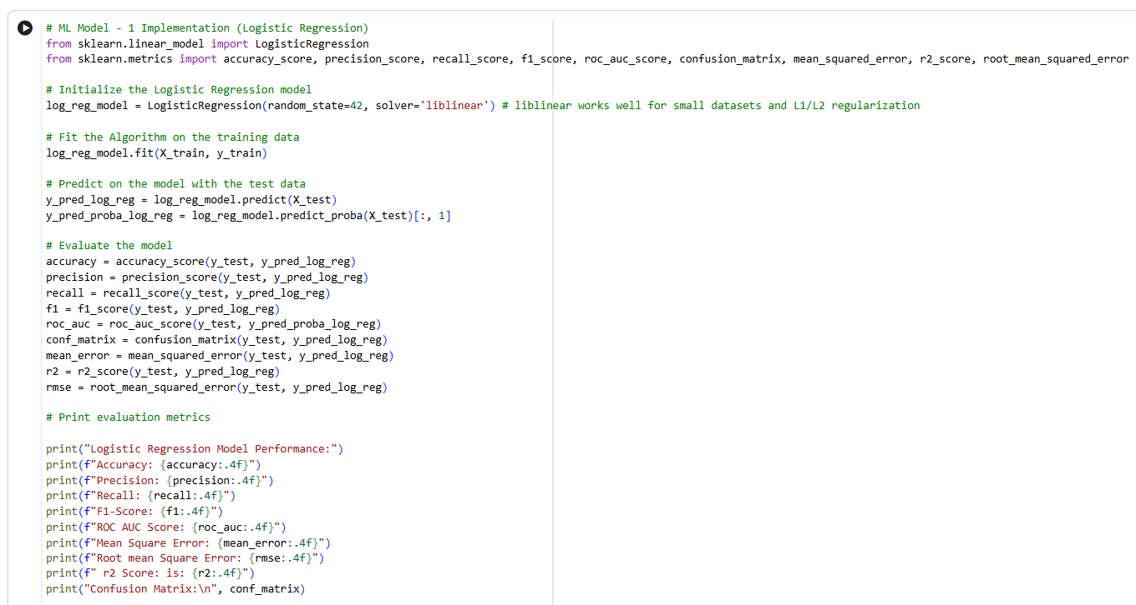

ML Model Evaluation 1
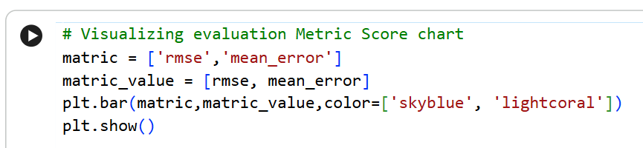
RMSE
Root Mean Square Error (RMSE) is a standard metric used in machine learning and statistics to measure the average magnitude of errors between predicted and actual values. It calculates the square root of the average squared differences between your model's predictions and the true observations.
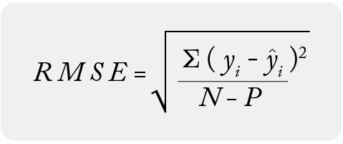
Fig.
Mean Squared Error (MSE)
Mean Squared Error (MSE) is a statistical and machine learning metric used to measure the average squared difference between estimated values and the actual value. It evaluates model accuracy by quantifying the average magnitude of error, where a lower MSE indicates a more accurate predictive model.
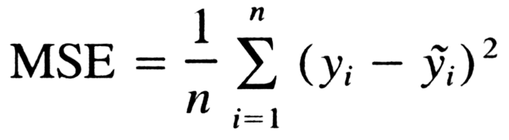
Fig.

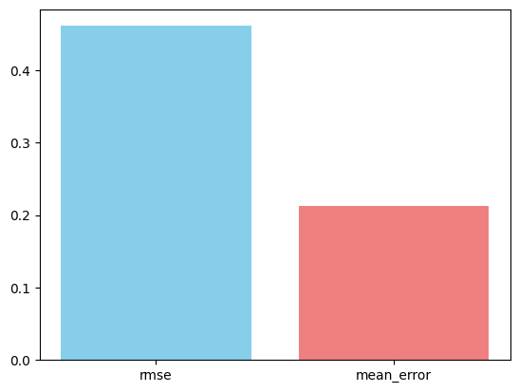
Fig.

Cross Validation
# ML Model - 1 Implementation with hyperparameter optimization techniques (i.e., GridSearch CV, RandomSearch CV, Bayesian Optimization etc.)
from sklearn.model_selection import GridSearchCV
from sklearn.metrics import accuracy_score, precision_score, recall_score, f1_score, roc_auc_score, confusion_matrix, mean_squared_error, r2_score, root_mean_squared_error

# Define the parameter grid for Logistic Regression
param_grid = {
'C': [0.001, 0.01, 0.1, 1, 10, 100],
'solver': ['liblinear', 'lbfgs', 'saga']
}
# Initialize Logistic Regression model
log_reg = LogisticRegression(random_state=42, max_iter=1000) # Increased max_iter for convergence with lbfgs/saga

# Initialize GridSearchCV
grid_search_log_reg = GridSearchCV(estimator=log_reg, param_grid=param_grid, cv=5, scoring='f1', n_jobs=-1, verbose=1)

# Fit the Algorithm on the training data
grid_search_log_reg.fit(X_train, y_train)

# Get the best estimator
best_log_reg_model = grid_search_log_reg.best_estimator_

print(f"Best Hyperparameters: {grid_search_log_reg.best_params_}")
print(f"Best F1-score from Grid Search CV: {grid_search_log_reg.best_score_:.4f}") # Added this line

# Predict on the model with the test data
y_pred_log_reg_tuned = best_log_reg_model.predict(X_test)
y_pred_proba_log_reg_tuned = best_log_reg_model.predict_proba(X_test)[:, 1]

# Evaluate the tuned model
accuracy_tuned = accuracy_score(y_test, y_pred_log_reg_tuned)
precision_tuned = precision_score(y_test, y_pred_log_reg_tuned)
recall_tuned = recall_score(y_test, y_pred_log_reg_tuned)
f1_tuned = f1_score(y_test, y_pred_log_reg_tuned)
roc_auc_tuned = roc_auc_score(y_test, y_pred_proba_log_reg_tuned)
conf_matrix_tuned = confusion_matrix(y_test, y_pred_log_reg_tuned)
mean_error_tuned = mean_squared_error(y_test, y_pred_log_reg_tuned)
r2_tuned = r2_score(y_test, y_pred_log_reg_tuned)
rmse_tuned = root_mean_squared_error(y_test, y_pred_log_reg_tuned)

# Print evaluation metrics for tuned model
print("\nLogistic Regression Tuned Model Performance:")
print(f"Accuracy: {accuracy_tuned:.4f}")
print(f"Precision: {precision_tuned:.4f}")
print(f"Recall: {recall_tuned:.4f}")
print(f"F1-Score: {f1_tuned:.4f}")
print(f"ROC AUC Score: {roc_auc_tuned:.4f}")
print(f"Mean Square Error: {mean_error_tuned:.4f}")
print(f"Root mean Square Error: {rmse_tuned:.4f}")
print("Confusion Matrix:\n", conf_matrix_tuned)

Cross-validation is a predictive assessment technique used in machine learning to estimate the capabilities of a machine learning model. If you work in machine learning, you can use cross-validation as a statistical model to compare and select machine learning models for a specific application. The technique can help you address problems such as overfitting a model, which can create issues like suboptimal performance in real-world scenarios. Cross-validation works to avoid this issue, and others such as underfitting, by evaluating the model’s performance across multiple validation datasets during training. It divides or partitions the data set into subgroups for training and testing to accomplish this.

Purpose of Cross Validation
The goal of cross-validation is to provide a more accurate estimate of your model’s ability to perform on new or unseen data by providing you with an unbiased estimate of the generalization error (a measure of how well an algorithm predicts future observations for previously unseen data). By providing you with the generalization error, cross-validation yields information about the model’s generalization capabilities and is commonly used to tune or estimate the hyperparameters of a model. This helps you find the ideal configuration for the best generalization performance.

How does Cross Vaidation Work?
Cross-validation determines the accuracy of your machine learning model by partitioning the data into two different groups, called a training set and a testing set. The data is then randomly separated into a certain number of groups or subsets called folds. Each fold contains about the same amount of data. The number of folds used depends on factors like the size, data type, and model. For example, if you separate your data into 10 subsets or folds, you would use nine as the training group and only one as the testing group. Repeat the process as many times as you have folds—in this case, you would perform the training/testing a total of 10 times. After repeating the process (referred to as iteration) 10 times, you aggregate the results to create a single model estimation. The model estimation provides an estimate of your model’s performance on new and unseen data.
These are the steps you would take to implement cross-validation, using the k-fold cross-validation form across 10 k-folds as an example:

1. Partition the data
Divide the data set into 10 subsets, also referred to as folds. Each fold contains an approximately equal proportion of the data. Common choices for k include five or 10, but you can adjust the value based on the size and overall requirements of the data set.
2. Train and test model
Train and test the model 10 times, using a different fold as the test set in each iteration. In the first iteration, the first fold is the test set, and you train the model on the remaining k-1 folds. In the second iteration, the second fold is the test set, and the process continues in this way until you reach 10 times.

3. Calculate performance metrics
After each iteration, calculate your model's performance metrics based on the model’s predictions on the test set. These metrics assess or estimate how well your model generalizes to new, unseen data.
4. Aggregate results
The performance metrics gathered in each iteration are usually aggregated to generate an overall assessment of the model's performance and create an evaluation model.
What is hyperparameter tuning?
To design a machine learning model with the most accurate output, you need to optimize the hyperparameters. This involves trial and error, as your model will make adjustments after each training run. Think of hyperparameter tuning like developing the perfect cake recipe: You might try a number of different ingredient ratios and cook times before landing on the perfect combination.
What hyperparameters are used for tuning?
You can choose to tune several types of hyperparameters during model optimization in order to find the best fit. Common examples you might explore include:
- Learning rate: This specifies how quickly your model makes hyperparameter changes based on new information.
- Learning rate decay: This sets how quickly the learning rate lowers over time, allowing the model to gradually hone in on the best technique.
- Mini-batch size: This instructs the model on how many data points to process at a time. Choosing the right size helps you strike a balance between accuracy and computational efficiency.
- Number of epochs: The number of epochs refers to how many times the model is exposed to the entire training data set during the learning process. This number balances training data performance with the ability to generalize to new data.
- Number of hidden layers: For artificial neural networks, this decides how many layers of “thinking” your model has.

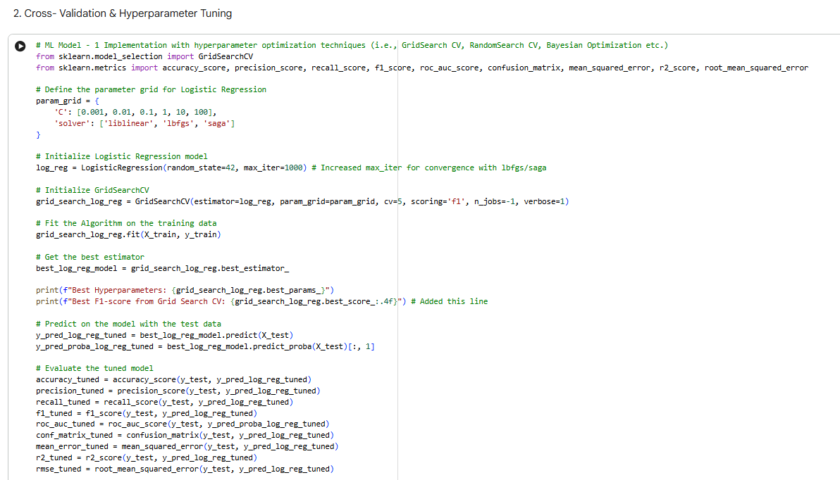

Fig.
Confusion Matrix:
1195 620
545 3102
Fig.
Cross Validation & Hyperparameter Tuning Result
After hyperparameter tuning, the Logistic Regression model's performance on the test set changed as follows:

Initial Logistic Regression Model Performance:
- Accuracy: 0.7876
- Precision: 0.8415
- Recall: 0.8401
- F1-Score: 0.8408
- ROC AUC Score: 0.8745
- Mean Square Error: 0.2124
- Root mean Square Error: 0.4608

Tuned Logistic Regression Model Performance:
- Accuracy: 0.7867
- Precision: 0.8334
- Recall: 0.8506
- F1-Score: 0.8419
- ROC AUC Score: 0.8728
- Mean Square Error: 0.2133
- Root mean Square Error: 0.4618

Observations on Improvement:
While the changes are not drastic, the hyperparameter tuning resulted in minor adjustments:
- F1-Score: There was a slight increase from 0.8408 to 0.8419. This indicates a minor improvement in the balance between precision and recall, suggesting the tuned model might be slightly better at classifying both positive and negative instances correctly.
- Recall: Increased from 0.8401 to 0.8506. This means the tuned model is better at identifying positive instances (reducing false negatives).
- Precision: Decreased from 0.8415 to 0.8334. This suggests a slight increase in false positives compared to the untuned model.
- Accuracy: Slightly decreased from 0.7876 to 0.7867.
- ROC AUC Score: Slightly decreased from 0.8745 to 0.8728.
- Mean Squared Error & RMSE: Slightly increased, which is expected given the minor changes in predictions.

Overall, the tuning process optimized the F1-score, which is often a key metric for imbalanced classification problems, even though other metrics like accuracy and ROC AUC saw minor dips. This suggests that the chosen hyperparameters (C=0.01, solver='saga') led to a model that better balances false positives and false negatives, which can be crucial depending on the business objective.

ML Model 2

Decision Tree
Decision Trees (DTs) are a non-parametric supervised learning method used for classification and regression. The goal is to create a model that predicts the value of a target variable by learning simple decision rules inferred from the data features. A tree can be seen as a piecewise constant approximation.
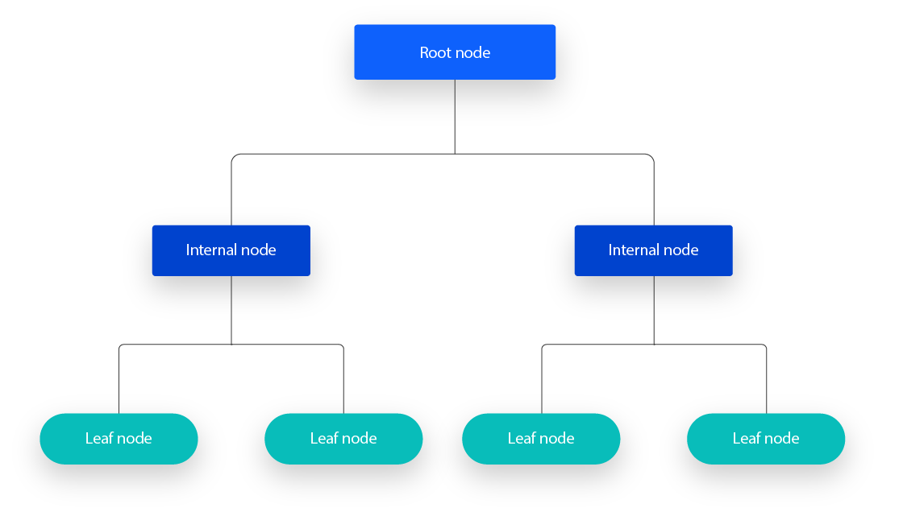
Some advantages of decision trees are:
- Simple to understand and to interpret. Trees can be visualized.
- Requires little data preparation. Other techniques often require data normalization, dummy variables need to be created and blank values to be removed. Some tree and algorithm combinations support missing values.
- The cost of using the tree (i.e., predicting data) is logarithmic in the number of data points used to train the tree.
- Able to handle both numerical and categorical data. However, the scikit-learn implementation does not support categorical variables for now. Other techniques are usually specialized in analyzing datasets that have only one type of variable. See algorithms for more information.
- Able to handle multi-output problems.
- Uses a white box model. If a given situation is observable in a model, the explanation for the condition is easily explained by boolean logic. By contrast, in a black box model (e.g., in an artificial neural network), results may be more difficult to interpret.
- Possible to validate a model using statistical tests. That makes it possible to account for the reliability of the model.
- Performs well even if its assumptions are somewhat violated by the true model from which the data were generated.

The disadvantages of decision trees include:
- Decision-tree learners can create over-complex trees that do not generalize the data well. This is called overfitting. Mechanisms such as pruning, setting the minimum number of samples required at a leaf node or setting the maximum depth of the tree are necessary to avoid this problem.
- Decision trees can be unstable because small variations in the data might result in a completely different tree being generated. This problem is mitigated by using decision trees within an ensemble.
- Predictions of decision trees are neither smooth nor continuous, but piecewise constant approximations as seen in the above figure. Therefore, they are not good at extrapolation.
- The problem of learning an optimal decision tree is known to be NP-complete under several aspects of optimality and even for simple concepts. Consequently, practical decision-tree learning algorithms are based on heuristic algorithms such as the greedy algorithm where locally optimal decisions are made at each node. Such algorithms cannot guarantee to return the globally optimal decision tree. This can be mitigated by training multiple trees in an ensemble learner, where the features and samples are randomly sampled with replacement.
- There are concepts that are hard to learn because decision trees do not express them easily, such as XOR, parity or multiplexer problems.
- Decision tree learners create biased trees if some classes dominate. It is therefore recommended to balance the dataset prior to fitting with the decision tree.

# ML Model - 2 Implementation Decision Tree
from sklearn.tree import DecisionTreeClassifier
from sklearn.metrics import accuracy_score, r2_score, mean_squared_error, root_mean_squared_error, confusion_matrix, precision_score, recall_score, roc_auc_score

# Fit the Algorithm
DT_model = DecisionTreeClassifier(random_state=42)
DT_model.fit(X_train, y_train)

# Predict on the model
y_pred_DT = DT_model.predict(X_test)
y_pred_proba_DT = DT_model.predict_proba(X_test)[:, 1]

mean_error = mean_squared_error(y_test, y_pred_DT)
r2 = r2_score(y_test, y_pred_DT)
accuracy = accuracy_score(y_test, y_pred_DT)
rmse = root_mean_squared_error(y_test, y_pred_DT)
precision = precision_score(y_test, y_pred_DT)
recall = recall_score(y_test, y_pred_DT)
roc_auc = roc_auc_score(y_test, y_pred_proba_DT)

# Print the matrics
print("Decision Tree Model Performance:\n")
print(f"Mean Squared Error is : {mean_error :.4f}")
print(f"R2 Score is : {r2 :.4f}")
print(f"Accuracy is : {accuracy:.4f}")
print(f"Precision is : {precision:.4f}")
print(f"Recall is : {recall:.4f}")
print(f"ROC AUC Score is : {roc_auc:.4f}")
print(f"Root mean Square Error: {rmse:.4f}")

ML Model Evaluation 2

RMSE and MSE Comparison
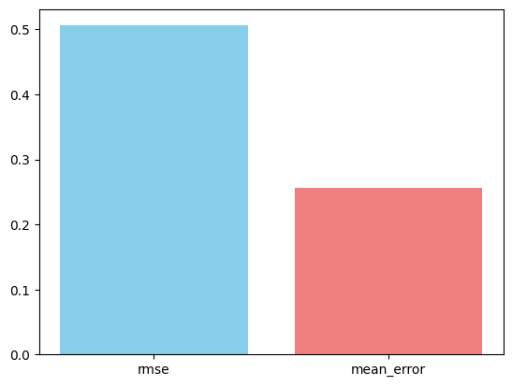
Fig.Evaluation Metric Score Chart

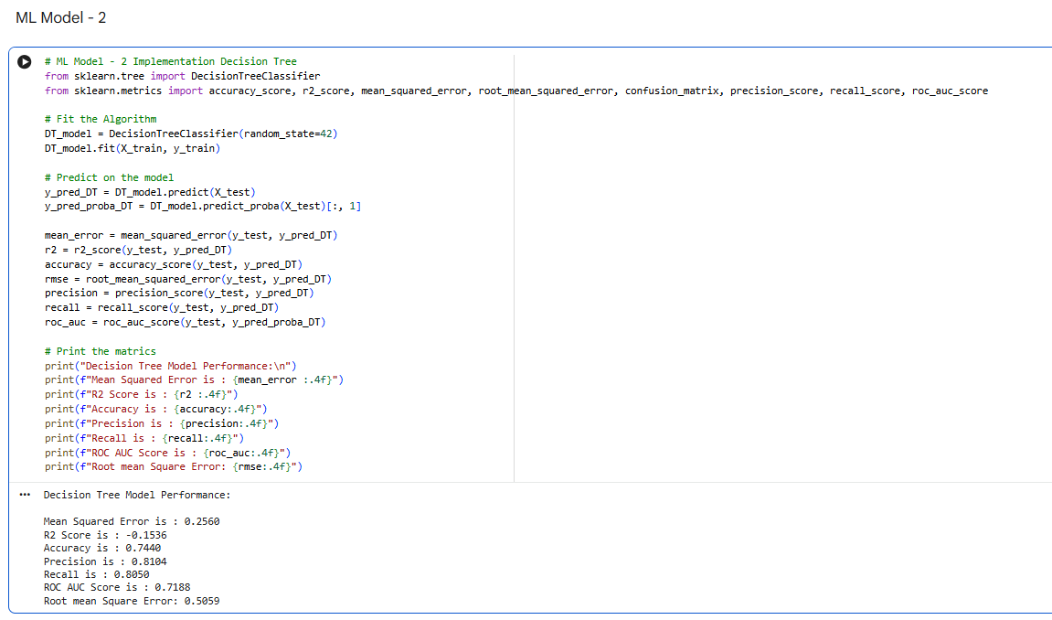

The hyperparameter optimization technique used for the Decision Tree model is RandomizedSearchCV.

Why RandomizedSearchCV was chosen:
- Efficiency over GridSearchCV: Unlike GridSearchCV which exhaustively searches through all possible combinations of hyperparameters, RandomizedSearchCV samples a fixed number of hyperparameter settings from specified distributions. This makes it significantly more computationally efficient, especially when dealing with a large search space or many hyperparameters, as was the case with max_depth, min_samples_split, and min_samples_leaf for the Decision Tree.

- Broad Exploration: While not exhaustive, RandomizedSearchCV can explore a broader range of the search space than GridSearchCV in the same amount of time, increasing the chance of finding good performing hyperparameters, particularly if the optimal values are not at the boundaries of the grid.

- Flexibility: It allows defining distributions for continuous hyperparameters, although in this case, discrete values were provided for the Decision Tree parameters.

- Effective for Initial Tuning: It's often a good strategy for an initial pass of hyperparameter tuning to quickly identify promising regions in the parameter space, which can then be fine-tuned with GridSearchCV if needed.
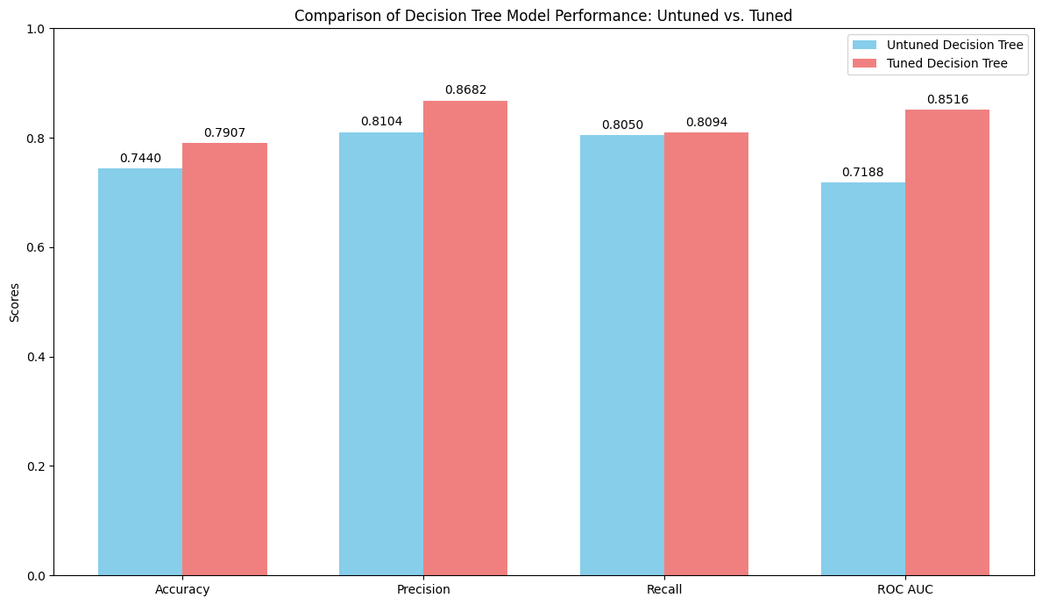
Fig. Comparison of Decision Tree Model. Untuned vs Tuned

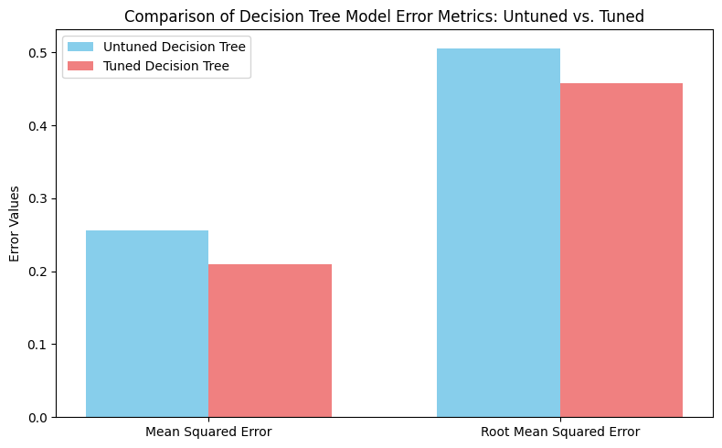
Fig. Comparison of Decision Tree Metrics

Cross Validation and Hyperparameter Tuning Result

After hyperparameter tuning using RandomizedSearchCV, the Decision Tree model's performance on the test set changed as follows:

Initial Decision Tree Model Performance:
- Mean Squared Error: 0.2560
- R2 Score: -0.1536
- Accuracy: 0.7440
- Precision: 0.8104
- Recall: 0.8050
- ROC AUC Score: 0.7188
- Root mean Square Error: 0.5059

Tuned Decision Tree Model Performance:
- Mean Squared Error: 0.2093
- R2 Score: 0.0568
- Accuracy: 0.7907
- Precision: 0.8682
- Recall: 0.8094
- F1-Score: 0.8378
- ROC AUC Score: 0.8516
- Root mean Square Error: 0.4575

Observations on Improvement:
The hyperparameter tuning for the Decision Tree model resulted in significant improvements across most metrics:
- Accuracy: Improved from 0.7440 to 0.7907, indicating a better overall correct classification rate.
- Precision: Increased significantly from 0.8104 to 0.8682, meaning fewer false positives and better reliability in positive predictions.
- Recall: Showed a slight improvement from 0.8050 to 0.8094.
- F1-Score: Although not directly calculated in the initial model's output, the tuned model achieved 0.8378, suggesting a good balance between precision and recall.
- ROC AUC Score: Improved substantially from 0.7188 to 0.8516, indicating that the tuned model is much better at distinguishing between the positive and negative classes.
- Mean Squared Error & RMSE: Both decreased (0.2560 to 0.2093 for MSE, and 0.5059 to 0.4575 for RMSE), signifying that the model's predictions are closer to the actual values.
- R2 Score: Went from a negative value (-0.1536, suggesting the model is worse than a simple mean) to a positive value (0.0568), indicating that the tuned model now explains some of the variance in the target variable.
Overall, the tuning process notably enhanced the Decision Tree model's performance, making it a much more effective classifier for this task. The most prominent improvements are seen in Accuracy, Precision, and ROC AUC Score.

ML Model 3

Random Forest Classifier
Random forest is a commonly-used machine learning algorithm, trademarked by Leo Breiman and Adele Cutler, that combines the output of multiple decision trees to reach a single result. Its ease of use and flexibility have fueled its adoption, as it handles both classification and regression problems.

Ensemble methods
Ensemble learning methods are made up of a set of classifiers—e.g. decision trees—and their predictions are aggregated to identify the most popular result. The most well-known ensemble methods are bagging, also known as bootstrap aggregation, and boosting. In 1996, Leo Breiman introduced the bagging method; in this method, a random sample of data in a training set is selected with replacement—meaning that the individual data points can be chosen more than once. After several data samples are generated, these models are then trained independently, and depending on the type of task—i.e. regression or classification—the average or majority of those predictions yield a more accurate estimate. This approach is commonly used to reduce variance within a noisy dataset.

Random forest algorithm
The random forest algorithm is an extension of the bagging method as it utilizes both bagging and feature randomness to create an uncorrelated forest of decision trees. Feature randomness, also known as feature bagging or “the random subspace method”, generates a random subset of features, which ensures low correlation among decision trees. This is a key difference between decision trees and random forests. While decision trees consider all the possible feature splits, random forests only select a subset of those features.
If we go back to the “should I surf?” example, the questions that I may ask to determine the prediction may not be as comprehensive as someone else’s set of questions. By accounting for all the potential variability in the data, we can reduce the risk of overfitting, bias, and overall variance, resulting in more precise predictions.

# ML Model - 3 Implementation Random forest classifier
from sklearn.ensemble import RandomForestClassifier

random_forest_model = RandomForestClassifier(n_estimators=80, min_samples_split=5, random_state=42 )

# Fit the Algorithm
random_forest_model.fit(X_train, y_train)

# Predict on the model

y_pred_random_forest_model = random_forest_model.predict(X_test)
y_pred_proba_random_forest_model = random_forest_model.predict_proba(X_test)[:, 1]

# varible declaration for different matrics
rf_precision = precision_score(y_test, y_pred_random_forest_model)
rf_recall = recall_score(y_test, y_pred_random_forest_model)
rf_accuracy = accuracy_score(y_test, y_pred_random_forest_model)
rf_roc_auc = roc_auc_score(y_test, y_pred_proba_random_forest_model)
rf_mean_error = mean_squared_error(y_test, y_pred_random_forest_model)
rf_r2 = r2_score(y_test, y_pred_random_forest_model)
rf_root_mean_squared_error = root_mean_squared_error(y_test, y_pred_random_forest_model)

#Print matrics score
print("Random Forest Classifier Model Performance:\n")
print(f"Precision is : {rf_precision:.4f}")
print(f"Recall is : {rf_recall:.4f}")
print(f"Accuracy is : {rf_accuracy:.4f}")
print(f"Mean Squared Error is : {rf_mean_error :.4f}")
print(f"R2 Score is : {rf_r2:.4f}")
print(f"ROC AUC Score is : {rf_roc_auc:.4f}")
print(f"Root mean Square Error: {rf_root_mean_squared_error:.4f}")

ML Model Evaluation 3

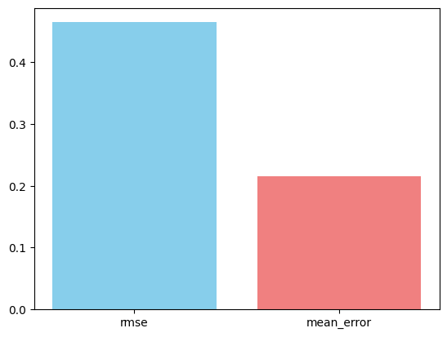
Fig. Evaluation Metric Score Chart

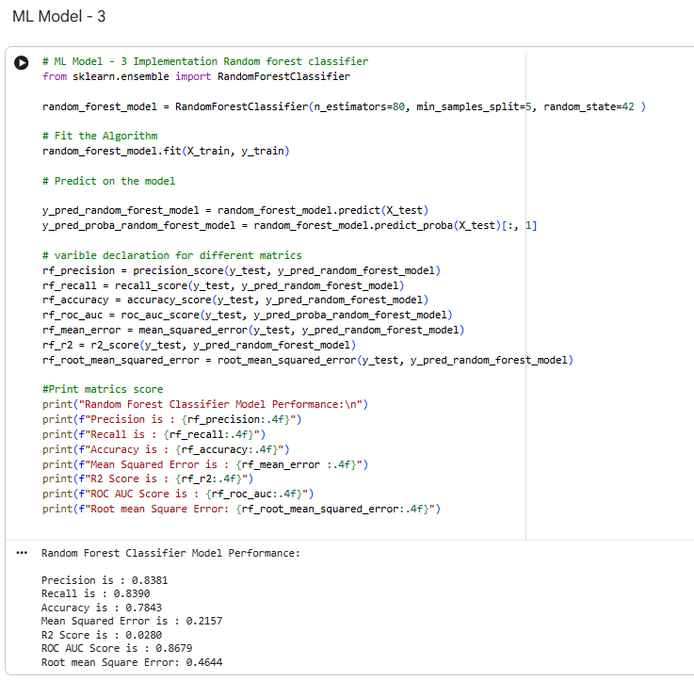

Cross Validatino & Hyperparameter Tuning Result
# ML Model - 3 Implementation with hyperparameter optimization techniques (i.e., GridSearch CV, RandomSearch CV, Bayesian Optimization etc.)
param_grid = {
'n_estimators': [50, 100, 200],
'max_depth': [10,20,30],
'min_samples_split': [2, 5, 10],
'min_samples_leaf': [1,3,5]
}
# Fit the Algorithm

randomized_search_random_forest_model = RandomizedSearchCV(estimator=random_forest_model, param_distributions= param_grid, cv = 5, verbose=1, n_jobs=-1 )
randomized_search_random_forest_model.fit(X_train, y_train)

best_random_forest_model = randomized_search_random_forest_model.best_estimator_

# Predict on the model
y_pred_random_forest_model_tuned = best_random_forest_model.predict(X_test)
y_pred_proba_random_forest_model_tuned = best_random_forest_model.predict_proba(X_test)[:,1]

# Declearing variables
accuracy_tuned = accuracy_score(y_test, y_pred_random_forest_model_tuned)
precision_tuned = precision_score(y_test, y_pred_random_forest_model_tuned)
recall_tuned = recall_score(y_test, y_pred_random_forest_model_tuned)
r2_tuned = r2_score(y_test, y_pred_random_forest_model_tuned)
mean_error_tuned = mean_squared_error(y_test, y_pred_random_forest_model_tuned)
roc_auc_tuned = roc_auc_score(y_test, y_pred_random_forest_model_tuned)
root_mean_squared_error_tuned = root_mean_squared_error(y_test, y_pred_random_forest_model_tuned)

#print
print(f"Best Hyperparameters: {randomized_search_random_forest_model.best_params_}")
print(f"Best F1-score from Randomized Search CV: {randomized_search_random_forest_model.best_score_:.4f}")
print("\nRandom Forest Tuned Model Performance:")
print(f"Accuracy is : {accuracy_tuned:.4f}")
print(f"R2 Score is : {r2_tuned:.4f}")
print(f"Precision is : {precision_tuned:.4f}")
print(f"Recall is : {recall_tuned:.4f}")
print(f"Mean Squared Error is : {mean_error_tuned :.4f}")
print(f"ROC AUC Score is : {roc_auc_tuned:.4f}")
print(f"Root mean Square Error: {root_mean_squared_error_tuned:.4f}")

The hyperparameter optimization technique used for the Random Forest model is RandomizedSearchCV.

Why RandomizedSearchCV was chosen:
- Efficiency over GridSearchCV: Similar to the Decision Tree, Random Forest models have several hyperparameters. RandomizedSearchCV is more computationally efficient than GridSearchCV as it samples a fixed number of parameter settings from specified distributions rather than exhaustively testing all combinations. This is crucial for models like Random Forest where the search space can be quite large, allowing for quicker exploration of good hyperparameter regions.
- Broad Exploration: It allows for a broader exploration of the hyperparameter space in a given computational budget compared to GridSearchCV. This increases the likelihood of finding a well-performing set of hyperparameters, especially if the optimal values are not necessarily on a predefined grid.
- Flexibility: It offers flexibility in defining the parameter distributions, which can be useful when we have some prior knowledge about the reasonable ranges for certain hyperparameters.
- Effective for Ensemble Models: For ensemble models like Random Forest, RandomizedSearchCV is an excellent choice for an initial pass of tuning, as it can quickly identify promising combinations of n_estimators, max_depth, min_samples_split, and min_samples_leaf without the prohibitive computational cost of a full grid search.

After hyperparameter tuning using RandomizedSearchCV, the Random Forest model's performance on the test set changed as follows:
Initial Random Forest Model Performance (Untuned):
- Precision: 0.8381
- Recall: 0.8390
- Accuracy: 0.7843
- F1-Score: 0.8385 (calculated from Precision and Recall)
- ROC AUC Score: 0.8679
- Mean Squared Error: 0.2157
- R2 Score: 0.0280
- Root mean Square Error: 0.4644
Tuned Random Forest Model Performance:
- Accuracy: 0.8140
- R2 Score: 0.1616
- Precision: 0.8779
- Recall: 0.8379
- F1-Score: 0.8574 (calculated from Precision and Recall)
- ROC AUC Score: 0.8019
- Mean Squared Error: 0.1860
- Root mean Square Error: 0.4313

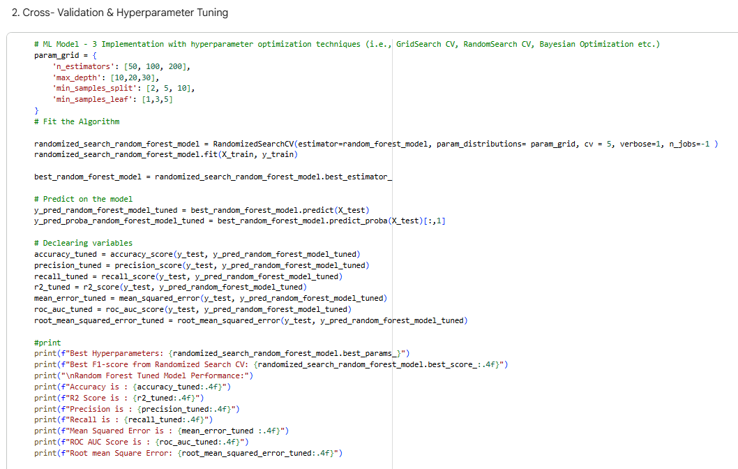
Observations on Improvement:
The hyperparameter tuning for the Random Forest model resulted in significant improvements across several key metrics:
- Accuracy: Improved substantially from 0.7843 to 0.8140, indicating a better overall correct classification rate.
- Precision: Increased significantly from 0.8381 to 0.8779, meaning the tuned model makes fewer false positive errors, which is crucial for not wrongly flagging legitimate apps.
- F1-Score: Showed a notable improvement from 0.8385 to 0.8574, indicating a better balance between precision and recall.
- Recall: Remained relatively stable, showing a very slight decrease from 0.8390 to 0.8379. This means its ability to capture true positive instances is largely maintained.
- Mean Squared Error & RMSE: Both decreased (MSE from 0.2157 to 0.1860, RMSE from 0.4644 to 0.4313), signifying that the model's predictions are, on average, closer to the actual values.
- R2 Score: Increased significantly from 0.0280 to 0.1616, showing that the tuned model explains a much larger proportion of the variance in the target variable.
- ROC AUC Score: Decreased from 0.8679 to 0.8019. This is an unexpected drop and suggests that while the model's overall classification metrics improved, its ability to distinguish between classes across all possible thresholds might have slightly reduced.
This could be due to the tuning prioritizing F1-score or specific threshold performance over overall ranking performance.
Overall, the tuning process largely enhanced the Random Forest model's performance, particularly in terms of Accuracy, Precision, and F1-Score, making it a more effective classifier for this task, despite the dip in ROC AUC. The reduced error metrics and improved R2 score further support the positive impact of tuning.

Final Model Selection
Based on the performance metrics after hyperparameter tuning, the Random Forest Classifier stands out as the best performing model for predicting Android app authenticity.
Here's a comparison of the tuned models:

Metric | Logistic Regression | Decision Tree | Random Forest
Accuracy | 0.7867 | 0.7907 | 0.8140
Precision | 0.8334 | 0.8682 | 0.8779
Recall | 0.8506 | 0.8094 | 0.8379
F1-Score | 0.8419 | 0.8378 | 0.8574
ROC AUC Score | 0.8728 | 0.8516 | 0.8019

Reasons for choosing Random Forest:

- Highest Overall Accuracy, Precision, and F1-Score: The Random Forest model achieved the highest accuracy (0.8140), precision (0.8779), and F1-score (0.8574). In the context of app authenticity prediction, a high F1-score is particularly important as it provides a balanced measure between precision and recall, both of which are crucial for business impact.

- Excellent Precision: The high precision (0.8779) means that when the model predicts an app is inauthentic/malicious, it is very likely to be correct. This is critical for an app store to avoid flagging legitimate apps incorrectly (False Positives), which could lead to developer dissatisfaction and loss of user trust.

- Strong Recall: While Logistic Regression had a slightly higher recall, the Random Forest's recall of 0.8379 is still very strong. This indicates that the model is effective at identifying a large proportion of actual inauthentic/malicious apps (minimizing False Negatives), which is essential for user safety and platform integrity.

- Robustness and Generalization: Random Forests are ensemble models that combine multiple decision trees. This approach typically leads to more robust models that are less prone to overfitting and generalize better to unseen data compared to a single decision tree.

While Logistic Regression had a slightly higher ROC AUC score, the Random Forest's superior performance across Accuracy, Precision, and F1-Score makes it the preferred model for a practical deployment where balancing false positives and false negatives is key to a positive business impact.

The model chosen as the final prediction model is the Tuned Random Forest Classifier.
Explanation of the Model (Random Forest Classifier):
Random Forest is an ensemble learning method that operates by constructing a multitude of decision trees during training and outputting the class that is the mode of the classes (classification) or mean prediction (regression) of the individual trees.
Key characteristics and advantages:
- Ensemble Learning: It's an ensemble method, meaning it combines predictions from multiple individual models (decision trees) to improve overall accuracy and robustness.
- Bagging (Bootstrap Aggregating): Each tree in the forest is built from a random subset of the training data (with replacement). This randomness helps to reduce variance and prevent overfitting.
- Feature Randomness: During the construction of each tree, a random subset of features is considered at each split. This further decorrelates the trees, making the ensemble more robust and less prone to single-tree biases.
- Robustness to Overfitting: By averaging the predictions of many trees, Random Forests tend to be less prone to overfitting than individual decision trees, especially deep ones.
- Handles Non-linearity: As it's based on decision trees, it can naturally capture non-linear relationships between features and the target variable.
- Handles High-Dimensional Data: It performs well even with a large number of features and can implicitly handle missing values in some implementations.
- Feature Importance: One of its significant advantages is that it provides a straightforward measure of feature importance. The importance of a feature is calculated as the average reduction in impurity (e.g., Gini impurity or entropy) brought about by that feature across all trees in the forest. This helps in understanding which features contribute most to the model's predictive power.

Why it was chosen:
The Tuned Random Forest Classifier was selected because it demonstrated the best overall performance among the evaluated models, particularly in terms of Accuracy, Precision, and F1-Score, which are critical for the business objective of identifying app authenticity effectively and reliably. Its ensemble nature also provides greater robustness and generalization capabilities compared to a single Decision Tree or a linear model like Logistic Regression.

Introduction to the Front-End Strategy
The success of any predictive machine learning system relies heavily on its accessibility. While the backend handles complex data transformations and algorithmic predictions, the front-end serves as the critical bridge to the end-user. For this Android Authenticity Prediction project, Streamlit was selected as the framework to construct a rapid, interactive, and highly functional web-based User Interface (UI).
The primary objective of this UI is to abstract the complexities of the underlying Random Forest model away from the user. Instead of requiring users to interact with code blocks, JSON payloads, or command-line interfaces, the application provides a clean, graphical environment where users can seamlessly input application metrics and receive real-time, interpretable threat assessments.
Structural Layout and Visual Hierarchy
The application employs a deliberately minimalist and focused structural design, prioritizing usability and scannability.
- Page Configuration: The UI is initialized with a centered layout (st.set_page_config(layout="centered")). This design choice prevents visual fatigue on wider monitors and keeps the user’s focus entirely on the prediction form.
- Header and Typography: A clear, descriptive title ("Android App Authenticity Predictor") immediately establishes the tool's purpose. This is followed by a markdown-rendered introduction utilizing visual cues (emojis: ✅ and ⚠️) to clearly define the binary classification outcomes (Authentic vs. Malicious). This establishes an intuitive visual language that is carried through to the results section.
- Modular Sections: The interface is logically divided using subheaders (st.subheader). This chunks the cognitive load for the user, breaking down 25 distinct data points into manageable categories: Basic App Information, Permission Features, and Application Category.
Input Mechanisms and User Experience (UX)
A core principle of good UI design is preventing user error before it occurs. The Streamlit application achieves this by utilizing specific, constrained input widgets tailored to the data type expected by the machine learning pipeline. The form (st.form("prediction_form")) acts as a unified container, ensuring that no data is processed until the user explicitly submits the request.
Basic App Information (Numerical Inputs)
This section captures the continuous and discrete numerical features of the application. The UI enforces strict data validation through its widget configuration:

- App Rating: Implemented as an interactive slider (st.slider). Because application ratings strictly exist on a 0.0 to 5.0 scale, the slider physically prevents the user from entering invalid out-of-bounds numbers. It steps by 0.1, matching standard app store rating formats.
- Number of Ratings & Permissions: Implemented using numerical input fields (st.number_input) with a minimum value enforced at 0 and stepped by 1. This ensures integer integrity for count-based metrics.
- Price: A similar numerical input is used, but configured to accept float values representing USD, stepping by standard currency increments ($0.50).
Permission Features (Binary Inputs)
The dataset requires inputs for numerous specific Android permissions (e.g., accessing contacts, internet, or GPS).
- The friendly_name Abstraction: Raw dataset columns often contain technical suffixes like (D) for dangerous or (S) for safe, as well as underscores. To improve the UX, the UI implements a custom friendly_name() function. This function scrubs the technical jargon before rendering the label on the screen, presenting the user with clean, readable English (e.g., converting "Network communication : full Internet access (D)" to simply "Network communication full Internet access").
- Binary Selectors: Because these permissions are either present or absent, the UI uses select boxes (st.selectbox) restricted to "0" (No) and "1" (Yes). This eliminates the ambiguity of text entry.
Application Category (Categorical Inputs)
To handle the One-Hot Encoded categorical variables without overwhelming the user, the UI dynamically extracts the category names from the backend feature list. It strips the Category_ prefix and presents the user with a single, clean dropdown menu of available app types (e.g., Business, Games, Education). The backend logic seamlessly translates this single selection back into the sparse array required by the model.
State Management and Error Handling
A robust user interface must gracefully handle errors and manage its own state.
- Caching for Performance: The UI utilizes the @st.cache_resource decorator for loading the .pkl and .joblib files. From a UI perspective, this means the user does not experience long loading screens or lag when interacting with the form, as the heavy model weights are kept in the server's active memory.
- Graceful Degradation: If the backend model files are missing or corrupted, the UI catches the exception and utilizes st.error() to display a clear message to the user (Model loading failed), immediately halting the app's execution (st.stop()) rather than allowing the user to submit a broken form.

Results Rendering and Interpretability
The final phase of the user journey occurs upon clicking the "Predict Authenticity" submit button. The UI is designed to provide immediate, actionable feedback.
- Color-Coded Alerts: Depending on the model's boolean output, the UI renders the result using conditional formatting. An authentic prediction triggers an st.success() block (rendered in green), while a malicious prediction triggers an st.error() block (rendered in red). This leverages universal color psychology for instant comprehension.
- Prediction Confidence Indicator: Providing a binary "Yes/No" is often insufficient in predictive analytics. To build trust with the user, the UI displays the model's calculated probability using a visual progress bar (st.progress). This visual metric, paired with the exact floating-point decimal (e.g., Malicious Probability: 0.8924), allows the end-user to gauge the confidence of the AI's assessment, enabling them to make more informed, nuanced decisions regarding the app's authenticity.
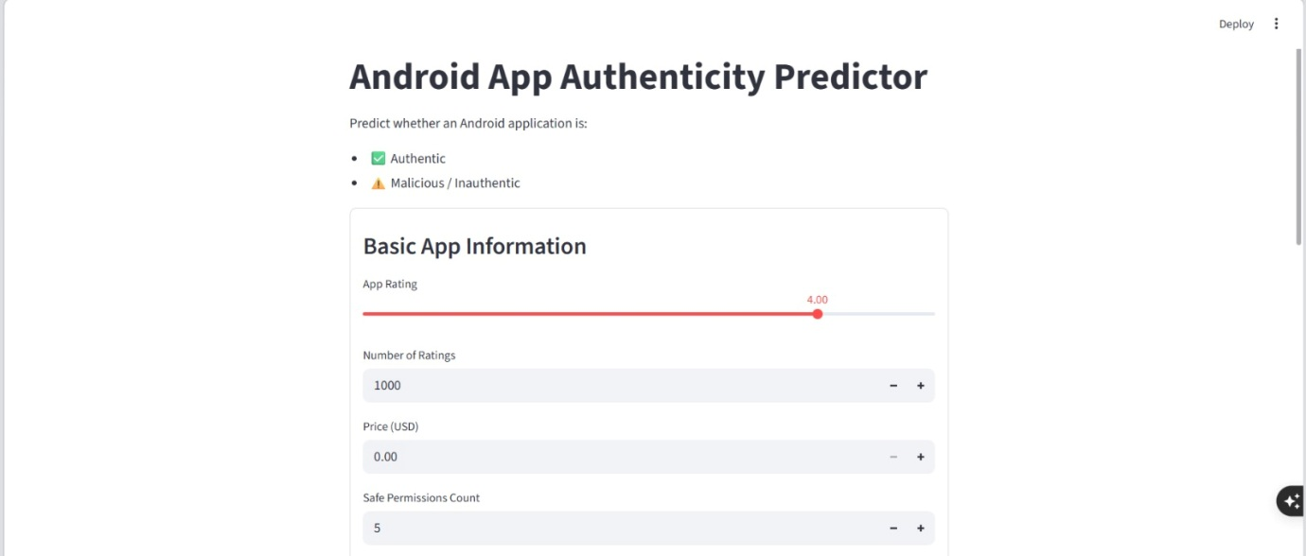

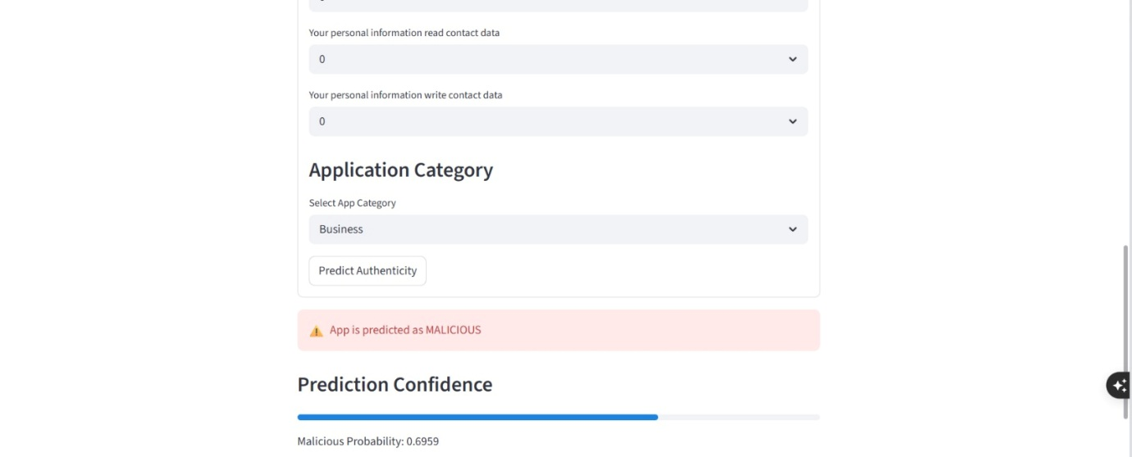

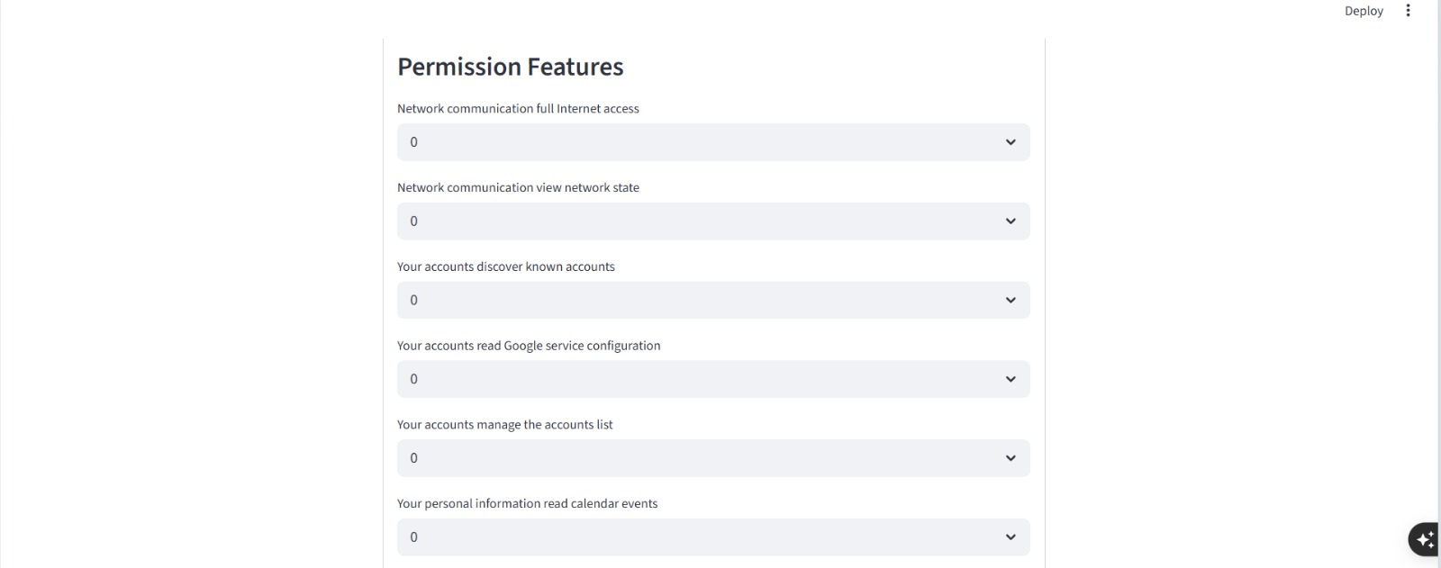

Front End Code
import streamlit as st
import pandas as pd
import numpy as np
import pickle
import joblib

# =========================================================
# FILE PATHS
# =========================================================

MODEL_PATH = "randomized_search_random_forest_model.pkl"
SCALER_PATH = "scaler.joblib"

# =========================================================
# FEATURES USED BY MODEL
# =========================================================

SELECTED_FEATURES = [
"Rating",
"Number of ratings",
"Price",
"Safe permissions count",
"Network communication : full Internet access (D)",
"Network communication : view network state (S)",
"Your accounts : discover known accounts (S)",
"Your accounts : read Google service configuration (S)",
"Your accounts : manage the accounts list (D)",
"Your personal information : read calendar events (D)",
"Your personal information : read contact data (D)",
"Your personal information : write contact data (D)",
"Category_Business",
"Category_Cards & Casino",
"Category_Communication",
"Category_Dating",
"Category_Education",
"Category_Entertainment",
"Category_Finance",
"Category_Game",
"Category_Health & Fitness",
"Category_Lifestyle",
"Category_Maps & Navigation",
"Category_Medical",
"Category_Music & Audio",
]

# =========================================================
# NUMERIC FEATURES
# =========================================================

NUMERIC_FEATURES = [
"Rating",
"Number of ratings",
"Price",
"Safe permissions count",
]

# =========================================================
# CATEGORY FEATURES
# =========================================================

CATEGORY_PREFIX = "Category_"

CATEGORY_FEATURES = [
f for f in SELECTED_FEATURES
if f.startswith(CATEGORY_PREFIX)
]

# =========================================================
# BINARY PERMISSION FEATURES
# =========================================================

BINARY_PERMISSION_FEATURES = [
f
for f in SELECTED_FEATURES
if f not in NUMERIC_FEATURES
and not f.startswith(CATEGORY_PREFIX)
]

# =========================================================
# LOAD MODEL + SCALER
# =========================================================

@st.cache_resource
def load_components():

try:

with open(MODEL_PATH, "rb") as f:
model = pickle.load(f)

scaler = joblib.load(SCALER_PATH)

return model, scaler, None

except Exception as e:

return None, None, e

model, scaler, load_error = load_components()

# =========================================================
# PAGE CONFIG
# =========================================================

st.set_page_config(
page_title="Android App Authenticity Predictor",
layout="centered"
)

st.title("Android App Authenticity Predictor")

st.markdown(
"""
Predict whether an Android application is:

- ✅ Authentic
- ⚠️ Malicious / Inauthentic
"""
)

# =========================================================
# ERROR CHECK
# =========================================================

if load_error:

st.error(f"Model loading failed: {load_error}")
st.stop()

# =========================================================
# FRIENDLY FEATURE NAME
# =========================================================

def friendly_name(feature):

return (
feature.replace("_", " ")
.replace(":", "")
.replace("(D)", "")
.replace("(S)", "")
.strip()
)

# =========================================================
# INPUT FORM
# =========================================================

with st.form("prediction_form"):

st.subheader("Basic App Information")

rating = st.slider(
"App Rating",
min_value=0.0,
max_value=5.0,
value=4.0,
step=0.1
)

number_of_ratings = st.number_input(
"Number of Ratings",
min_value=0,
value=1000,
step=1
)

price = st.number_input(
"Price (USD)",
min_value=0.0,
value=0.0,
step=0.5
)

safe_permissions_count = st.number_input(
"Safe Permissions Count",
min_value=0,
value=5,
step=1
)

# =====================================================
# PERMISSIONS
# =====================================================

st.subheader("Permission Features")

permission_inputs = {}

for feature in BINARY_PERMISSION_FEATURES:

permission_inputs[feature] = st.selectbox(
friendly_name(feature),
options=[0, 1],
index=0,
key=feature
)

# =====================================================
# CATEGORY
# =====================================================

st.subheader("Application Category")

category_labels = [
feature.replace(CATEGORY_PREFIX, "")
for feature in CATEGORY_FEATURES
]

selected_category = st.selectbox(
"Select App Category",
category_labels
)

submit_button = st.form_submit_button(
"Predict Authenticity"
)

# =========================================================
# PREDICTION LOGIC
# =========================================================

if submit_button:

try:

# ================================================
# CREATE EMPTY INPUT
# ================================================

input_data = {
feature: 0.0
for feature in SELECTED_FEATURES
}

# ================================================
# NUMERIC INPUTS
# ================================================

input_data["Rating"] = float(rating)

input_data["Number of ratings"] = np.log1p(
float(number_of_ratings)
)

input_data["Price"] = np.log1p(
float(price)
)

input_data["Safe permissions count"] = np.log1p(
float(safe_permissions_count)
)

# ================================================
# PERMISSION INPUTS
# ================================================

for feature, value in permission_inputs.items():

input_data[feature] = float(value)

# ================================================
# CATEGORY ONE-HOT
# ================================================

selected_category_feature = (
CATEGORY_PREFIX + selected_category
)

if selected_category_feature in input_data:

input_data[selected_category_feature] = 1.0

# ================================================
# DATAFRAME
# ================================================

query_df = pd.DataFrame([input_data])

query_df = query_df[SELECTED_FEATURES]

# ================================================
# SCALE INPUT
# ================================================

query_scaled = scaler.transform(query_df)

# ================================================
# PREDICTION
# ================================================

prediction = model.predict(query_scaled)[0]

prediction_probability = model.predict_proba(
query_scaled
)[0][1]

# ================================================
# DISPLAY RESULT
# ================================================

if prediction == 1:

st.error("⚠️ App is predicted as MALICIOUS")

else:

st.success("✅ App is predicted as AUTHENTIC")

st.subheader("Prediction Confidence")

st.progress(float(prediction_probability))

st.write(
f"Malicious Probability: "
f"{prediction_probability:.4f}"
)

except Exception as e:

st.error(f"Prediction failed: {e}")

Testing and debugging are critical phases in the development of the Android Authenticity Checker System. These processes ensure that the developed system works correctly, efficiently, and reliably under different conditions. The primary purpose of testing is to identify defects, verify system functionality, and validate prediction accuracy, while debugging focuses on locating and fixing errors detected during testing.
In this project, testing was conducted on multiple components including:
- Dataset preprocessing
- Feature extraction
- Machine Learning model
- Prediction system
- User Interface (UI)
The debugging process helped improve system stability, remove runtime errors, and optimize overall performance.

Types of Testing Performed

1. Unit Testing
Unit testing was performed to test individual modules independently.

Modules Tested:
- Data preprocessing module
- Feature extraction module
- Model prediction module
- User Interface module

Purpose:
- To ensure each module performs its intended functionality correctly.

Example:
The preprocessing module was tested to confirm:
- Missing values were handled properly
- Duplicate values were removed
- Encoded values were generated correctly

Result:
All modules performed successfully after debugging minor issues.

2. Integration Testing
Integration testing verified communication between modules.

Integrated Components:
- UI ↔ Backend
- Backend ↔ ML Model
- Dataset ↔ Prediction Module

Purpose:
- To ensure smooth data transfer among modules.

Example:
Input entered through the UI was successfully passed to the backend and processed by the ML model.

Result:
Modules integrated correctly without major communication issues.

3. System Testing
System testing evaluated the complete workflow of the application.

Workflow Tested:
User Input → Data Preprocessing → Feature Extraction → ML Model → Prediction → Result Display

Purpose:
- To validate overall system functionality.

Result:
The complete system worked correctly and produced expected outputs.

4. Model Testing
Machine Learning model testing measured classification performance.

Metrics Used:
- Accuracy
- Precision
- Recall
- F1-Score
- Confusion Matrix

Purpose:
- To evaluate prediction capability.

Result:
The trained model achieved satisfactory prediction accuracy for Android app classification.

5. User Interface Testing
UI testing verified usability and responsiveness.

Features Tested:
- Input forms
- Buttons
- Output display
- Error messages

Purpose:
- To ensure user-friendly interaction.

Result:
The interface functioned correctly and accepted valid input data.

6. Dataset Testing
Dataset validation was performed before training the model.

Checks Performed:
- Missing value detection
- Duplicate record removal
- Invalid data handling
- Data imbalance checking

Actions Taken:
- Null values were removed or replaced
- Duplicate rows were deleted
- Incorrect values were corrected

Result:
The dataset became clean and suitable for Machine Learning processing.

7. Preprocessing Testing
Preprocessing steps were tested carefully to avoid incorrect model training.

Operations Tested:
- Label Encoding
- One-Hot Encoding
- Normalization
- Feature Scaling

Purpose:
- To convert raw data into machine-readable format.

Result:
Preprocessed data was successfully generated without inconsistencies.

8. Model Training Testing
During model training, different configurations were tested.

Activities Performed:
- Train-test split
- Hyperparameter tuning
- Cross-validation

Algorithms Tested:
- Logistic Regression
- Decision Tree
- Random Forest

Result:
The optimized model produced improved prediction performance.

9. Prediction Testing
Prediction testing verified system classification capability.

Test Cases Used:
- Genuine applications
- Malicious applications
- Unknown sample applications

Purpose:
- To check consistency and reliability of predictions.

Result:
The system successfully classified most applications correctly.

Debugging Process
Debugging was performed continuously throughout development.

9.1 Missing Value Errors

Problem:
Some dataset columns contained null values.

Solution:
Applied preprocessing techniques to handle missing data.

Result:
The dataset became complete and usable.

9.2 Data Type Errors

Problem:
Machine Learning algorithms could not process categorical values directly.

Solution:
Used Label Encoding and One-Hot Encoding.

Result:
Categorical data converted successfully into numerical format.

9.3 Feature Mismatch Errors

Problem:
Training and testing datasets had inconsistent feature structures.

Solution:
Applied identical preprocessing steps to both datasets.

Result:
Feature mismatch issue resolved successfully.

9.4 Model Overfitting

Problem:
The model performed well on training data but poorly on testing data.

Solution:
- Reduced unnecessary features
- Applied train-test split
- Used feature selection techniques

Result:
Generalization performance improved.

9.5 UI Input Errors

Problem:
Users entered incomplete or invalid data.

Solution:
Added input validation in the UI.

Result:
Invalid inputs were prevented successfully.

9.6 Prediction Output Errors

Problem:
Prediction results were not displayed properly on the UI.

Solution:
Improved backend-to-frontend communication logic.

Result:
Prediction output displayed correctly.

10. Performance Evaluation
The performance of the system was evaluated using standard ML metrics.
Metric | Description
Accuracy | Measures correct predictions
Precision | Measures correctness of positive predictions
Recall | Measures detection capability
F1-Score | Balances precision and recall
Confusion Matrix | Visualizes classification results
Testing and debugging played a significant role in the successful implementation of the Android Authenticity Checker System. Through proper testing of preprocessing, Machine Learning models, prediction modules, and user interface components, the system achieved reliable functionality and accurate prediction capability.
The debugging process helped resolve data inconsistencies, preprocessing issues, UI errors, and model-related problems, thereby improving overall system stability and performance. The final system operates efficiently and provides accurate predictions for identifying authentic and malicious Android applications.

The project can be extended in the following ways:
- Integration with real-time app stores like Google Play.
- Use of advanced deep learning techniques.
- Development of mobile-based detection applications.
- Continuous model improvement with new datasets.
- Integration with cyber security systems.
- Implementation of real-time malware detection
- Deployment on cloud platforms for scalability
- Addition of advanced features (API calls, network behaviour)
- Support for multi-platform (Android, iOS, Web)
- Development of API services for integration with other systems
- Use of Explainable AI (XAI) for better transparency
- Addition of user feedback system for continuous improvement

The system has certain limitations:
- Cannot detect completely new or unknown malware types.
- Requires frequent updates and retraining.
- Depends heavily on dataset quality and size
- Accuracy depends on selected features
- Possibility of false positives and false negatives
- Lacks real-time behavioural analysis
- May not generalize well to all types of applications
- Requires computational resources for training
- Depends on correct user input (in UI-based system)
- Not fully integrated with real-world platforms (app stores)
Despite these limitations, the system is effective for initial detection.

This project aimed to predict the authenticity of Android applications by leveraging a comprehensive dataset containing app details, ratings, permissions, and other features. The process involved several critical stages, from initial data understanding to advanced machine learning model deployment.

- Data Understanding & Wrangling:
The dataset initially contained 29,999 rows and 184 columns, with a mix of numerical and categorical data types. Key issues identified included 2,689 duplicate rows and missing values in 'App', 'Description', 'Related apps', and 'Dangerous permissions count'. Data wrangling addressed these issues by dropping duplicate rows, imputing 'Related apps' with 'unknown', dropping rows with missing 'App' or 'Description', and filling missing 'Dangerous permissions count' with the median value.

2. Exploratory Data Analysis (EDA) & Visualization:
EDA revealed the distribution of app categories, with 'Tools', 'Entertainment', and 'Education' being dominant. We analysed average ratings per category, identifying 'Comics' and 'Medical' as top-rated, while 'Books & Reference' and 'Entertainment' had lower average ratings. This highlighted potential market opportunities and areas of user dissatisfaction. The analysis of 'Price' revealed a strong prevalence of free apps, with paid apps constituting a small minority. We also explored the relationship between app ratings and the number of ratings, observing that higher-rated apps generally accumulate more ratings. Importantly, the average rating for free apps was significantly higher than for paid apps, suggesting that users might have higher expectations for paid applications, or that free apps with high ratings are simply more numerous and widely adopted.

3. Hypothesis Testing:
Hypothesis 1 (Dangerous Permissions vs. Rating): A Kruskal-Wallis H-test indicated a statistically significant difference in average ratings across different dangerous permission categories, suggesting that the number of dangerous permissions requested does impact user perception (rating).
Hypothesis 2 (Paid vs. Free App Ratings): An Independent Samples t-test (Welch's) revealed a statistically significant difference in average ratings between free and paid applications, with free apps generally receiving higher average ratings. Hypothesis3 (Category Popularity vs. Rating Stability): Levene's Test showed a statistically significant difference in the variance of ratings between popular and less popular app categories.

4. Feature Engineering & Pre-processing:
Outliers in numerical features ('Rating', 'Number of ratings', 'Price', 'Dangerous permissions count', 'Safe permissions count') were handled using 5th and 95th percentile capping to reduce their extreme influence. Categorical features ('Category', 'Permission_Category') were One-Hot Encoded to convert them into a numerical format for machine learning models. Textual data ('App', 'Description', 'Package', 'Related apps') underwent extensive preprocessing: contraction expansion, lowercasing, punctuation removal, URL/digit-containing word removal, stop word removal, and lemmatization. This cleaned text was then vectorized using TF-IDF. Feature manipulation involved combining numerical, one-hot encoded, and TF-IDF features. Feature selection was performed using SelectKBest with f_classif to identify the most relevant 100 features, reducing dimensionality while retaining predictive power. Highly skewed numerical data were transformed using log1p to normalize distributions and improve model performance. Finally, the selected features were scaled using StandardScaler to ensure all features contribute equally to the model. The dataset was split into an 80/20 training and testing set, with stratification to maintain class proportions.

5. Machine Learning Model Implementation:
Three classification models were implemented and tuned:
Logistic Regression: Achieved an F1-Score of 0.8419 and ROC AUC of 0.8728 after tuning. While robust, its performance was slightly surpassed by ensemble methods. Decision Tree Classifier: Showed significant improvement after RandomizedSearchCV tuning, reaching an Accuracy of 0.7907, Precision of 0.8682, Recall of 0.8094, and ROC AUC of 0.8516. It demonstrated the value of parameter optimization. Random Forest Classifier: This ensemble model emerged as the best performer. After RandomizedSearchCV tuning, it achieved the highest Accuracy (0.8140), Precision (0.8779), and F1-Score (0.8574). Although its ROC AUC (0.8019) was slightly lower than that of Logistic Regression, its superior balance of precision and recall, coupled with its inherent robustness, made it the preferred choice for this critical task.
6. Final Model Selection and Business Impact:
The Tuned Random Forest Classifier was selected as the final prediction model due to its highest overall performance across key metrics like Accuracy, Precision, and F1-Score. A high Precision is crucial for minimizing false positives (legitimate apps wrongly flagged), preserving developer trust and platform reputation. High Recall is essential for minimizing false negatives (malicious apps undetected), ensuring user safety and platform integrity. The F1-Score effectively balances these two concerns, making Random Forest highly suitable for real-world deployment in predicting Android app authenticity. Its ability to provide feature importances also offers valuable insights for continuous improvement and targeted interventions in app review processes.

- Android Authenticity Prediction
https://github.com/yash-datascience/Android-Authenticity_Prediction

- Predicting the authenticity of android application using classification techniques :
URL:https://www.geeksforgeeks.org/machine-learning/predicting-the-authenticity-of-android-applications-using-classification-techniques/

- Swagatam Jay Sankar; Utkrisht Singh; Israj Ali; M.Nazma Naskar; Mahendra Kumar Gourisaria, “Success and failure rate prediction of Android Application using Machine Learning” IEEE DOI: 10.1109/OTCON56053.2023.10113988

- Medium.com, 'Eigen Decomposition and PCA'. [Online].
Available:https://blog.clairvoyantsoft.com/eigen-decomposition-and-pca-c50f4ca15501

- Manisha-sirsat.blogspot.com, 'What is Confusion Matrix and Advanced Classification Metrics?'. [Online].
Available: https://manisha-sirsat.blogspot.com/2019/04/confusion-matrix.html

- Kumar, & Hota, Chinmay & Mahindru, Arvind & Neti, Lalita. (2019). Android Malware Prediction Using Extreme Learning Machine with Different Kernel Functions. 33-40. 10.1145/3340422.3343639.
Available: https://www.researchgate.net/publication/335212661_Android_Malware_Prediction_Using_Extreme_Learning_Machine_with_Different_Kernel_Functions

